[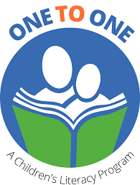](https://www.google.com/imgres?imgurl=https%3A%2F%2Fmiro.medium.com%2Fmax%2F1378%2F1*pIjQn_ff11_FLVJSLmT8og.png&imgrefurl=https%3A%2F%2Fmedium.com%2F%40yunchou0510%2Fui-case-study-web-design-development-one-to-one-literacy-1d7bf1fb63c6&tbnid=1lpDj0BR9nwi-M&vet=10CAkQxiAoAWoXChMI8Ir4k8a98AIVAAAAAB0AAAAAEAM..i&docid=E50sqrwR8EByZM&w=689&h=909&itg=1&q=one%20to%20one%20children's%20reading%20program%20logo%20image&client=firefox-b-d&ved=0CAkQxiAoAWoXChMI8Ir4k8a98AIVAAAAAB0AAAAAEAM)

**WORD GAMES**

**and**

**ACTIVITIES**

**a resource book of word games and activities for ONE TO ONE tutoring sessions**



**2023**

WORD GAMES and ACTIVITIES

*This**binder includes descriptions of word games and activities to support ONE TO ONE tutoring sessions. PDF files of the worksheets that support several of the games are in the ONE TO ONE section of the Salt Spring Literacy website - https://saltspringliteracy.org.*

INTRODUCTION

PLAYING WITH WORDS page 5

QUOTES FROM RESEARCH page 7

BASIC WORD LISTS

Introduction to Basic Word lists page 9

Dolch 220 word List page 9

Dolch noun list page 10

Fry first 100 word list page 10

Fry second 100 word list page 11

Fry third 100 word list page 11

ACTIVITIES USING INDIVIDUAL LETTERS

Letter Grab Bag page 13

Word Scramble page 13

Build the Word page 13

Rhyming Pairs page 13

Spaghetti Words page 13

GAMES USING HIGH FREQUENCY WORD CARDS

Go Fish page 15

Concentration (Memory) page 15

Word War page 15

STOP page 16

Lucky Duck (NOT) page 16

Pig and Stop page 16

Game Boards page 16

ADDITIONAL WORD GAMES and ACTIVITIES

Word Tic Tac Toe page 17

Hangman page 18

Word Sketches page 18

Boggle page 18

Spelling Battleship page 18

GAMES and ACTVITIES WITH DICE

Roll, Pick a Letter, Build a Word page 19

Roll, Say, Keep page 19

Roll to Write a Word page 19

Roll and Retell page 19

EXTENDED ACTIVITIES

SMALL WHITE BOARD ACTIVITIES page 21

Word Games page 21

Phonemic Awareness Activities page 21

ALTERNATE ACTIVITIES and GAMES page 23

Sentence Strips page 23

Fold and Cut Booklets page 23

WWWWH (Who, What? When? Why? Where? How?) page 23

KWL (Know, Wonder, Learned) page 23

GAMES WITH SOUNDS page 25

Talking Like Turtles page 25

Presto Chango page 25

Word Ladders page 25

Which One Doesn’t Belong? page 25

Riddles page 25

Clapping Words page 25

GAMES WITH WORDS page 27

Word Theater page 27

20 Questions page 27

Ring a Word page 27

Fun With Sentences page 27

By the Numbers page 27

Tongue Twister Sentences page 27

Out, Word Out page 27

ABC Sentences page 27

Build Up page 27

GAME CARDS

Dolch words with images for Lucky Duck and PIG page 31

STOP cards page 45

Individual Letter Cards page 75

GAME DESCRIPTIONS

Go Fish page 83

Concentration (Memory) page 85

Word War page 87

STOP page 89

Lucky Duck (NOT) page 91

Pig and Stop page 93

Game Boards page 95

Word Tic Tac Toe page 97

Hangman page 99

Boggle page 101

Roll, Pick a Letter, Build a Word page 103

Roll, Say, Keep page 105

Roll to Write a Word page 107

Roll and Retell page 109

WORKSHEETS

Game Boards page 113

WORD Tic Tac Toe page 117

Hangman page 119

Alternate Hangman page 121

Boggle page 123

Spelling Battleship page 125

Roll, Pick a Letter, Build a Word page 127

Roll, Say, Keep grid page 129

Roil to Write a Word page 131

Roll and Retell page 133

Fold and Cut Booklets page 135

WWWWH (Who, What? When? Why? Where? How?) page 139

KWL (Know, Wonder, Learned) page 141

Finding Right Fit Books page 143

Word Searches page 145

**REFERENCES**

**PROVINCIAL ONE TO ONE RESOURCES**

You can find further information on tutoring resources on the provincial ONE TO ONE website:

https://one-to-one.ca/get-involved/volunteer-resources/

**PROVINCIAL FACEBOOK PAGE**

The provincial ONE TO ONE regularly posts ideas and news on their Facebook page:  
https://www.facebook.com/one2oneliteracy/

**GAME VIDEOS**

The provincial ONE TO ONE website includes a number of videos demonstrating how to play word games. They are:

Go Fish: <https://vimeo.com/386882550>

Game Boards: <https://vimeo.com/189807020>

Tic Tac Toe: <https://vimeo.com/188429654>

Pig and Stop: <https://vimeo.com/190609163>

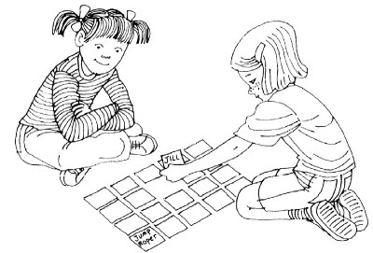Lucky Duck, NOT: https <https://vimeo.com/190609163>

Snow Man: <https://vimeo.com/386882697>

**PLAYING WITH WORDS**

Word games are an enjoyable way to help students build the word recognition skills needed to read fluently. Often games can help engage students who are resistant to reading or are simply having difficulty with reading, writing, or dealing with anything connected to words. As well, games can be a way to approach shy or insecure students and build their confidence.

This resource book describes games and activities focussing on high frequency sight words that can be used during tutoring sessions. You can use them as:

* warmup activities
* ways to break up the lesson when your student has a short attention span
* a conclusion to your lesson
* a way to build a relationship with a new or reluctant student
* an activity to use when working with two or more students

The following question and answers are from a list on the Think Tank Scholar website (https://www.thinktankscholar.com/pages/how-do-you-teach-sight-words-at-home).

WHAT ARE SIGHT WORDS?

Sight words, otherwise known as frequency sight words, are common words that are memorized by “sight” so they can be easily recognized when they are seen in any type of text. Usually these words have unusual spelling patterns that can’t be sounded out by using basic phonetic patterns. Sight words make up approximately 75% of the words used in beginning student’s print materials. The purpose of using sight words in beginning text is so students can focus on the meaning of what they read, and they don’t have to spend time using strategies to decode the sounds of the words.

WHY USE SIGHT WORDS?

It is important to use sight words for many reasons, mainly because most students have working knowledge of these words already, they use them in their daily speech, and they hear them often. For many of these words, the meanings won’t have to be taught as the students inherently know what they mean. Thus, sight words are used to teach reading since the words are used in about 50-75% of the reading materials for that particular age range. It is of the opinion that readers who master these words are more apt to become accurate, fluent, confident, and successful readers

HOW DO YOU USE SIGHT WORDS?

Sight words are the most common words in beginning reading text (making up about 50-75% of the words) and are identified through several lists (Dolch, Fry, Top 150, Core Curriculum, etc.). They also make up about 50% of the words in a typical newspaper and are used often in conversational speech. It is best to teach readers to recognize these words as they are usually neither phonetically-based nor follow typical spelling patterns. Memorizing these words helps with the ease and fluency of reading so readers can recognize similar words and also concentrate on newer and more difficult ones.

HOW TO TEACH SIGHT WORDS TO STRUGGLING READERS?

It is important to be patient and encourage the struggling reader, so they are more apt to be willing and motivated to spend time learning to read. Another important aspect is to spend one-on-one time with the reader, so they have quality time to practice, increasing their chances to integrate the words into long-term memory. Pointing to the words, using flashcards, repeating the words, seeing the words in context, and using alternate mediums like music or games helps to build sight word recognition and also helps to integrate a variety of learning styles for maximal learning.

WHAT IS THE DOLCH LIST?

The Dolch list is a list of commonly used English words (not nouns); most of the words must be recognized by sight and cannot be sounded out phonetically. They get their name from Edward William Dolch, PhD, who compiled the list and published it in his 1948 book *Problems in Reading.* The word list is based on children’s reading materials and consists of the most frequently used 220 words that children must know to read. In addition, Dolch compiled a separate list of 95 words that are nouns that are most commonly used.

HOW MANY DOLCH SIGHT WORDS ARE THERE?

There are 220 words that make up the Dolch sight word list. These words were compiled by Dr. Edward Dolch in 1948 and are divided into five groups: pre-primer, primer, first grade, second grade, and third grade. There is a separate group of Dolch noun words, a list of 95 common nouns. The Dolch sight words are based on the children’s reading materials in the 1930s-40s.  Many of these words can’t be sounded out and must be learned by sight. That is why they are called sight words. These words are used to teach early readers and reading fluency.

HOW DO YOU USE DOLCH SIGHT WORDS?

You could display words on a word wall or have children write their own word books to include the given sight words. Assorted games can be played to target Dolch sight words like word Bingo, a version of GO Fish, concentration, etc. Worksheets offer a variety of activities to see the words, underline the words, match them in some way, arrange letters/ sentences to spell words and sentences, etc. The goal is to expose children to the words in many different ways, so all learning modalities are tapped to meet the individualized learning styles and maximize reading interest and success.

WHAT ARE FRY WORDS?

In 1996, Dr. Edward Fry compiled a list of 1,000 words broken up into groups of 100 based on frequency of use. These words make up 90% of the words used in children’s reading materials. Furthermore, the first 100 words on Fry’s list are the most frequently occurring words in the English language according to his research. Fry words are an expanded, updated list of sight words (i.e., compared to the Dolch list of 220 sight words compiled by Edward Dolch in 1948). Many advocates of beginning literacy programs support having their students practice these words to build reading success.

WHAT IS THE DEFINITION OF A WORD FAMILY?

Word families are groups of words that have a common pattern or feature. They may have either a similar sound or they have the same letter combinations. For example, one basic word family are “at” sounding words: bat, cat, fat, hat, mat, pat, rat, sat, tat, and vat. There are 37 common word families in the English language, according to Wylie and Durrell who identified these words in 1970. Many nursery rhymes contain word families. Teaching word families is a strategy to help kids read many words with ease and to develop rhyming skills to expand their reading sight vocabulary.

**QUOTES FROM RESEARCH SUPPORTING THE USE OF WORD GAMES.**

* One of the most important skills for effective, independent reading is the ability to recognize words accurately and rapidly (Adams, 1990; Hendricks & Rinsky, 2007; NICHHD; Rasinski & Padak, 2008).
* Students in the primary grades are often highly motivated to learn through developmentally appropriate play, rather than typical paper and pencil activities (Vygotsky, 1978; Wood, 2007).
* To promote literacy skills essential for becoming successful readers, students need to develop automatic word recognition skills by the second or third grade (Adams; Snow, Burns, & Griffin, 1998).
* Accurate word recognition is affected by the amount of time it takes the reader to recognize the word. Immediate and accurate recognition enables readers to quickly construct and process the meaning of the text. Readers who do not have the ability to recognize words with automaticity must devote their working memory to utilizing word recognition strategies, and this disrupts their ability to comprehend the written text. When readers have to frequently switch their attention from word recognition to comprehension this creates an exhausting demand on working memory capacity. Moreover, if readers are not able to accurately recognize one or two key words and/or sight words in the text, this can affect their ability to understand the text (Harris & Sipay 1990; LaBerge & Samuels, 1974)
* Rasinski and Padak (2008) suggest that students of average intelligence need approximately 35 exposures to a word before they can quickly recognize the word. However, less able learners need about 55 exposures to a word before they can quickly recognize the word.

**INTRODUCTION to WORD LISTS**

A number of basic words are difficult to portray with pictures or hard to sound out through phonics methods. Once children have learned and memorized these basic sight words, they read more fluently and with greater comprehension. Both the Dolch Basic 220 most frequently used words and the Fry 1000 most frequently used words are useful references for planning games and activities.

Although the Dolch 220 list was developed by Edward William Dolch, PhD in 1948 it is still widely used today and highly respected by both teachers and parents. Dolch compiled his sight word list based on the words most frequently used in children's reading books in the 1930's and 1940's. These words make up 50 to 70 percent of any general text.

In 1996, Dr. Fry expanded on [Dolch's sight word lists](http://www.uniqueteachingresources.com/dolch-sight-words.html) when he researched and published a book titled "Fry 1000 Instant Words." In his research, Dr. Fry found the following results:

* 25 words make up approximately 1/3 of all items published.
* 100 words comprise approximately 1/2 of all of the words found in publications.
* 300 words make up approximately 65% of all written material.

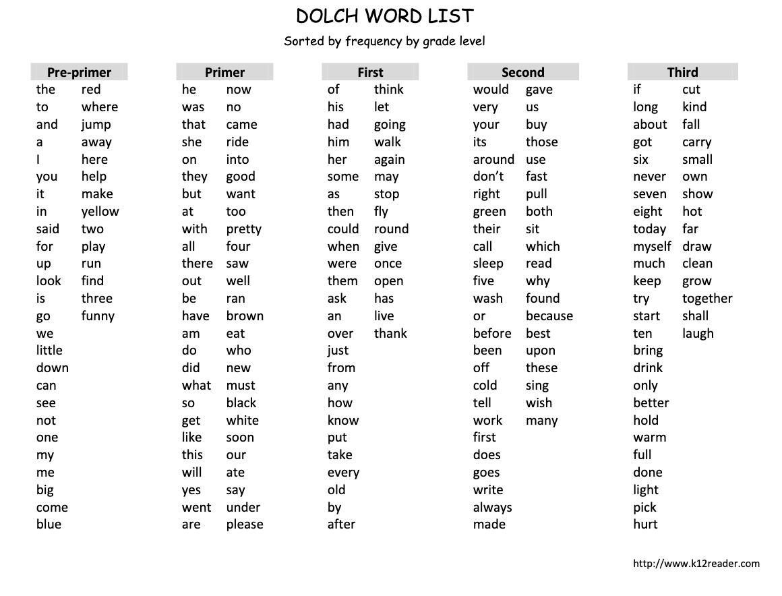

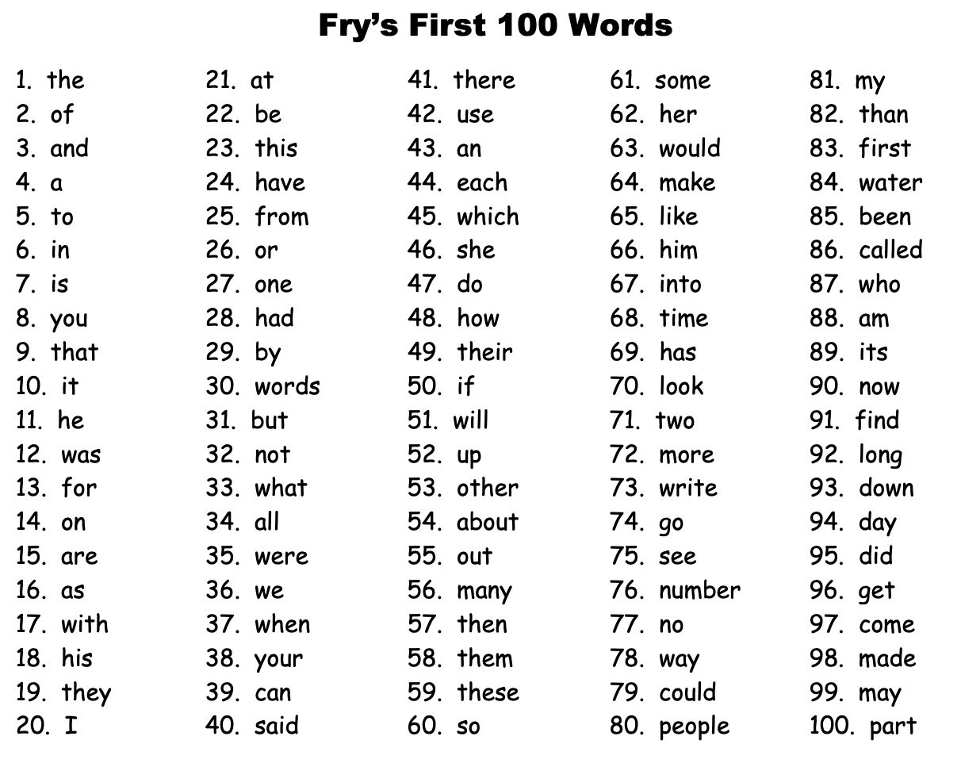

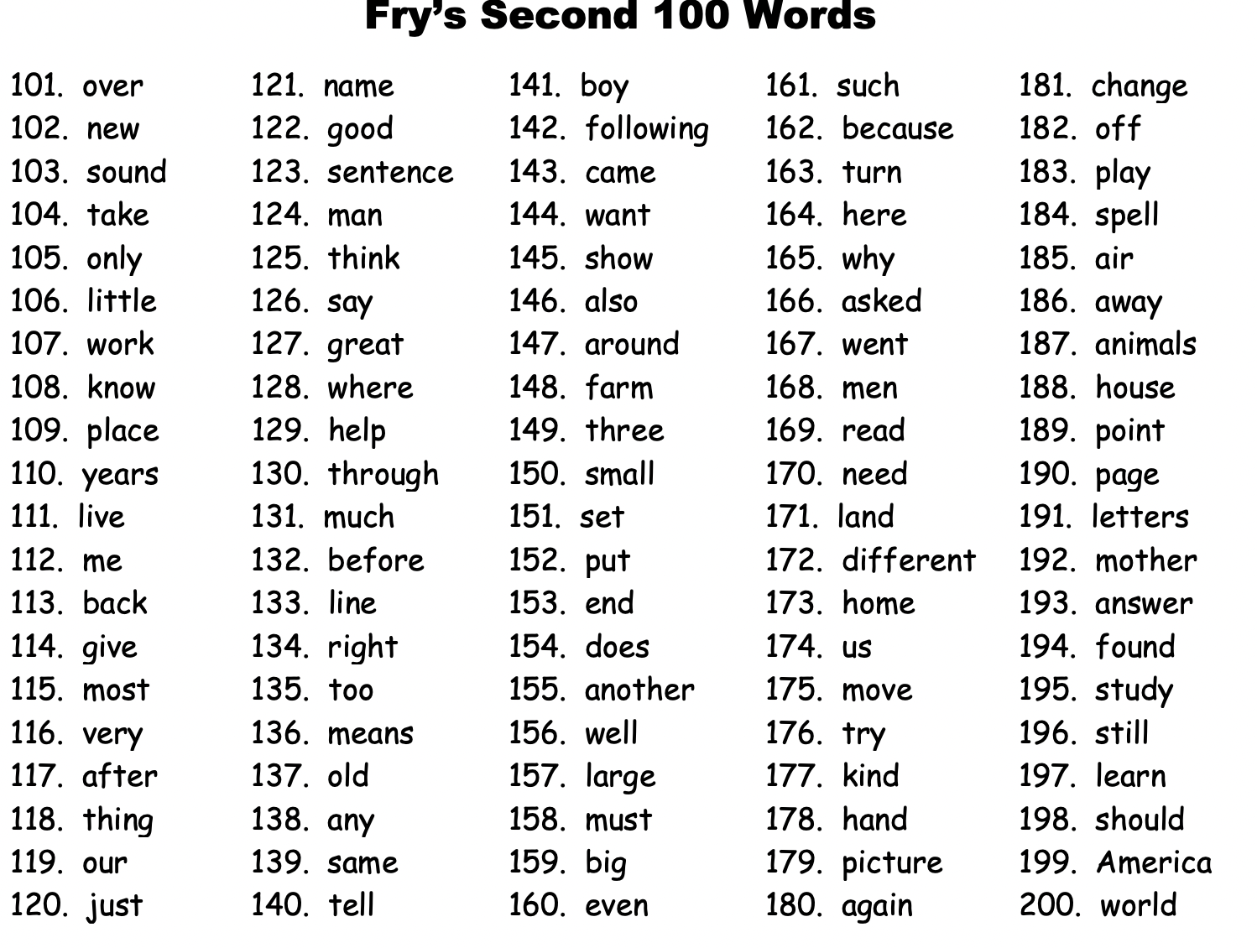

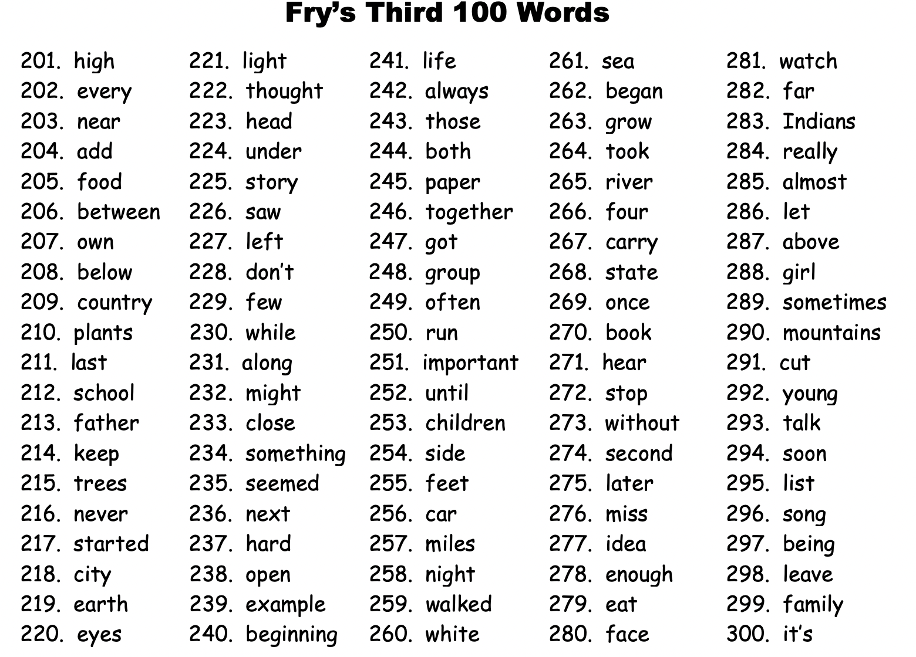

**ACTIVITIES USING INDIVIDUAL LETTERS**

*Use magnetic letters on a magnetic board for these activities or cut out individual letters. (templates for individual word cards start on page 31. As well, a PDF of letter cards is available on Literacy website)*

**LETTER GRAB BAG**

Place one set of letters in a drawstring bag and have the student draw out one letter at a time. They then think of a word that begins with the letter. You can write the word down or ask them to.

OR

Place two sets of letters in a drawstring bag and have the students draw out 8 letters. Ask them to rearrange them into as many words as they can. You can write these down or ask them to.

**WORD SCRAMBLE**

Select individual letters to scramble words. You can use single words or short phrases. Ask the student to unscramble the words. For example:

**eth yob the boy**

**BUILD THE WORD**

Build several words using individual letters. Show the student how to change the word by adding or taking away a letter to make a new word. For example:

**me he**

**hat sat**

**dog bog**

**RHYMING PAIRS**

Make a 3-letter word with individual letters. Say the word and add a word with the individual letters that rhymes. For example:

**bug**

**rug**

**SPAGHETTI WORDS**

Make a ‘spaghetti’ word with individual letters. Ask the student to make as many little words out of the spaghetti word as they can. For example:

**Spaghetti word: Vancouver**

**van cove run cane**

**can ran cover cave**

**GAMES USING HIGH FREQUENCY WORD CARDS**

*Handouts describing most games are available in the Game Description section of this binder starting on page 81.*

**GO FISH**



Play Fish with your student or use it with two or more students. Assemble pairs of word cards, 9-12 pairs per player.  Deal seven cardsto each player.  Scatter the rest face down in the center of the playing area.  Players first look for matches in the cards they were dealt. They place the pairs face up on the playing surface and keep their unmatched cards in their hand. Then the game is played like *Go Fish*.  Players take turns asking others for cards they need to make matches, e.g. “Do you have *book?”*   If the other person has the word, it is given to the player who asked.  If not, the player is told to “Go Fish”, and they must draw a card from the upside-down cards laid out on the table. Play continues until someone is out of cards. The winner is the one with the most pairs of cards.

**CONCENTRATION (MEMORY)**

Use about 10 pairs of word cards (20 words all together).  Shuffle the cards and lay them face down in a rectangle.  Now you and the student (or another student) can take turns turning up two cards at a time.  If the cards match, the player can keep them.  If they do not match, turn the cards back over (you can leave them face up for students when they have difficulty remembering where the cards are). The winner is the player with the most cards.

**WORD WAR**

This game is played like the card game *War*.  Use a set of high frequency cards such as the Dolch list or the Fry list. All word cards are dealt to the players.  Each player turns a card over and says the word on it.  The player whose word is longest (alternatively, first in alphabetical order) wins the cards.  In cases of ties, another card is turned over.  Play continues until all cards have been turned over. The winner is the player with the most cards.

**STOP** *(PDF of cards included in the Game Card section of this binder (starting on page 81) and available on the Literacy website.)*

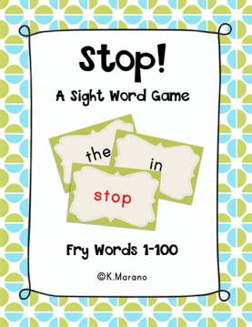This game includes duplicate cards of the words on Fry’s list of high frequency word along with several cards with the word STOP on them. Shuffle the cards and place them face down on the table. They can be in a stack or scattered. The first player begins by turning the cards over one at a time. They must be able to read the word correctly to continue their turn. If they cannot read the word, the play passes to the next player. As well, if the card says STOP it is the next player’s turn. The game is over when all the cards have been turned over.

**LUCKY DUCK (NOT)**: *Template for additional cards available with Dolch frequency word cards in the Game Card section of this binder starting on page 31)*

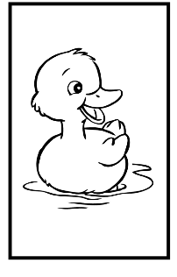Lucky Duck is similar to STOP and can be used with the same cards or a deck of cards from the Dolch or Fry word lists. Add cards with NOT and LUCKY DUCK to a deck of word cards. NOT cards are like STOP cards. The player’s turn is over unless they have an active Lucky Duck card. When a player turns over a Lucky Duck card, they keep it and continue turning cards over until they turn a NOT card over when they can use it to continue playing. They can only use a Lucky Duck card once.

**PIG:**  *Template for additional cards available with Dolch frequency word cards in the Game Card section of this binder starting on page 31.)*

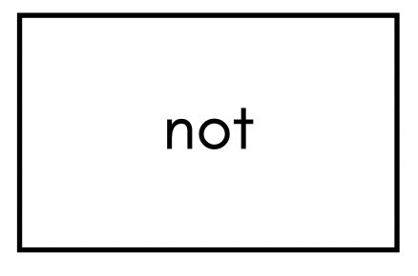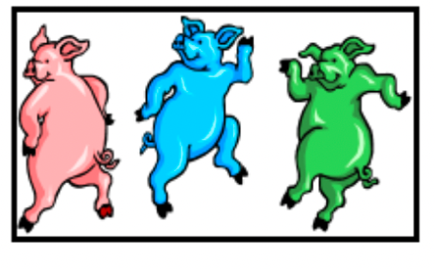Add 4 Pig cards and 4 Stop cards to a deck of sight vocabulary words to practice. Begin play by turning all the cards upside down and spreading them around the table. The first player declares how many words they think they can correctly read (limit of 1 to 4) before getting a PIG or STOP card. They then choose one card at a time and read each word as they choose the card. Their turn continues until they read the number declared, misses a word, or until they draw either a PIG or STOP card. A STOP card automatically ends the turn. The PIG and STOP cards remain active and must be turned face down on the table. The player may keep any words chosen and read correctly when they turn over a STOP card. A PIG card automatically ends the turn and any words chosen and read correctly in that turn have to go back to the table. Play continues until only the 4 PIG and 4 STOP cards remain.

**GAME BOARDS**

*Templates available in the Worksheet section of this binder (page 113). PDF copies are available on the Salt Spring Literacy website)*

Use a blank gameboard or work with the player to design their own. Begin play by turning a set of high frequency word cards upside down in a pile. Players alternate turns. The player rolls the die and must read the number of cards indicated by the number showing. For example, if a 4 comes up on the die, the player must read four words correctly before they can move 4 spaces on the gameboard. If the player is unable to read all 4 words correctly, they may move as many spaces as corresponds to the number of words they did read correctly. The first player to reach the finish is the winner.

**ADDITIONAL WORD GAMES AND ACTIVITIES**

**TIC TAC TOE:** A *template is available in the worksheet section of this binder (page 117) and a PDF of grid available on the Literacy website)*

****Work with your student to choose 9 words from a book they have read and write one in each square of a tic tac toe grid. Decide who will use X and who will use O on their turn. Start with the O player who will choose a square to read the word. If the player reads the word correctly, they may write O over the word. Then the X player chooses a word to read and write an X over. The first player to complete a straight line of three X’s or O’s wins the game.

**HANG MAN**: *Templates are available in the worksheet section of this binder (page119 and 121) and a PDF of grid is available on the Literacy website)*

Select a word or phrase from a book that the student has just read. For quick reference to the word, use a bookmark to keep track of the page it is located on. Place one dash on the bottom of the game board for each letter of the word or words chosen. Leave a larger space between words.

[a b c d e f g h I j k l m n o p q r s t u v w x y](https://www.google.com/imgres?imgurl=https%3A%2F%2Flh3.googleusercontent.com%2F2THSVIRiC2mG0D98QWRiOqo4Mc9Dt4shNHUy6YytvcJ50gIszHb8sqvvhnH-neny-w%3Ds100-rw&imgrefurl=https%3A%2F%2Fplay.google.com%2Fstore%2Fapps%2Fdetails%3Fid%3Dcom.benjaminwirtschafter.hangman%26hl%3Den_ZA&docid=v5IciAyfF_e5cM&tbnid=H5qDdcaZM-JolM%3A&vet=10ahUKEwjCoIGSkOnlAhWVlp4KHcmqD3QQMwgxKAYwBg..i&w=100&h=100&itg=1&hl=en-CA&bih=681&biw=1141&q=transparent%20hangman%20game&ved=0ahUKEwjCoIGSkOnlAhWVlp4KHcmqD3QQMwgxKAYwBg&iact=mrc&uact=8)

[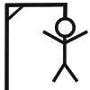](https://www.google.com/imgres?imgurl=https%3A%2F%2Flh3.googleusercontent.com%2F2THSVIRiC2mG0D98QWRiOqo4Mc9Dt4shNHUy6YytvcJ50gIszHb8sqvvhnH-neny-w%3Ds100-rw&imgrefurl=https%3A%2F%2Fplay.google.com%2Fstore%2Fapps%2Fdetails%3Fid%3Dcom.benjaminwirtschafter.hangman%26hl%3Den_ZA&docid=v5IciAyfF_e5cM&tbnid=H5qDdcaZM-JolM%3A&vet=10ahUKEwjCoIGSkOnlAhWVlp4KHcmqD3QQMwgxKAYwBg..i&w=100&h=100&itg=1&hl=en-CA&bih=681&biw=1141&q=transparent%20hangman%20game&ved=0ahUKEwjCoIGSkOnlAhWVlp4KHcmqD3QQMwgxKAYwBg&iact=mrc&uact=8)

If the word is dog, draw three spaces, like this: __ __ __.

Ask the student to guess one letter at a time or they can guess the entire word or words. Fill in the letter everywhere it appears on the appropriate dash (or dashes) each time the student guesses correctly. Use the letters on top of the page to keep track of the letters the student guesses. Circle the letters that are guessed correctly and put an X through letters that were guessed but not correct. Add one body part to the drawing each time the letter chosen is not in the word. Begin by drawing a head attached to the short vertical line (the "noose"). Add eyes, ears, nose, hair, body, legs, and arms. You may also wish to make your drawings very elaborate - one ear at a time, a neck, and a belly button - so that students will have a lot of guesses. This game can be played with two or more students who will take turns choosing the word to be guessed.

a b c d e f g h I j k l m n o p q r s t u v w x y

You may choose to play a variation of Hang Man.

**Blow the House Down:** Instead of drawing parts of a man, draw parts of a house such as walls, doors, windows, chimney. Add doorknobs, curtains, doorsteps for extra details if needed. If the house is completed before the player can guess all the letters, the big bad wolf comes and blows the house down.

**Melt the Snowman**: Draw parts of a snowman and add details such as nose, pipe hat, buttons. If the player cannot guess the word or words before the snowman is completed a warm wind will come and melt the snowman.

**WORD SKETCHES**



This game is based on *Pictionary*.  To play, first select several words from a text the student has read.  Put each word on a small slip of paper, and put the slips of paper in a cup.  Then play the game like *Pictionary*. You and your student each select a word and make a sketch that shows its meaning.  You might want to set a timer for about one minute for sketching.  Then trade sketches and each of you can guess the other’s word.

**BOGGLE:** A *(template available in the worksheet section of this binder (page 123)*

Use this game with more advanced readers. Begin by placing letters in the grid in the upper left-hand corner of the worksheet. You may want to do this before your tutoring session, or you may choose to do it with the student you are supporting. Direct the student to make as many words as they can in a set time using the letters on the board. Each letter can be used only once in each word. Finish the game by scoring the words. Words must be at least 3 letters long to score points.

3 letter words = 1 point; 4 letter words = 2 points; 5 letter words = 3 points; 6 or more letter words = 5 points

**SPELLING BATTLESHIP:** *template in the worksheet section of this binder (page 125)*

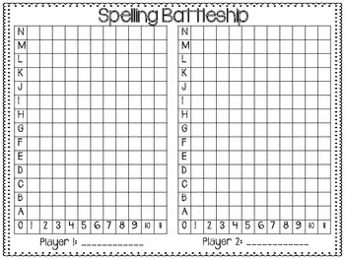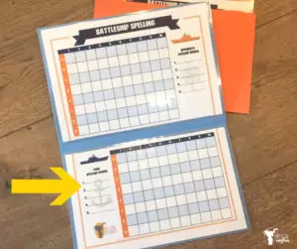This is a two player game. Players need to sit across from each other with a shield between them. Alternatively, you can place the two templates on each side of a file folder that can be opened in an L shape. Each player uses a score sheet with two sections: MY WORDS and OPPONENT’S WORDS.

Before playing each student secretly fills in one side of the game board (MY WORDS) with up to five words from a page in a book they are reading. The words may be written horizontally or vertically—or diagonally to make it more challenging for older players—but not backwards. Words may touch each other, but they cannot overlap. When both students are finished filling their words in, play begins.

Players take turns calling out coordinates. For example, when it is a player’s turn, they will call out the row and column such as F 12. If a player's opponent has a letter in the corresponding box, the opponent says “hit” and tells the other player what letter is in the box. If the box is empty, the opponent says “miss.” If it was a hit, the player who made the shot writes the letter on their OPPONENT'S WORDS grid at the proper coordinates. If it was a miss, the player marks the box with a dot.

At the same time, the opponent marks their grid. If it was a hit, the opponent circles the letter in the MY WORDS grid box. If it was a miss, the opponent marks the box with a dot.

If the shot was a hit, the player goes again. The player may guess the word instead of calling out coordinates. If the word was correct, the player must spell the word correctly to his or her opponent. If the word is spelled correctly, the opponent will say, “You sunk my (word)!” If the word was not guessed correctly or not spelled correctly, it counts as a miss.

The first player to sink all his or her opponent's spelling words is the winner.

*Tip:* Be sure both players put “hits” and “misses” in their correct grid boxes!

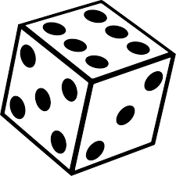**GAMES and ACTIVITIES WITH DICE**

**ROLL, PICK A LETTER, BUILD A WORD:** *A template is available in the worksheet section of this binder (page 127) and a PDF of grid is available on the Literacy website)*

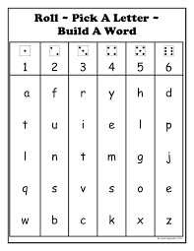The player rolls a die and writes down (or chooses a magnetic letter) from the column corresponding to the number on the die. For example, if the player rolls 4, they can choose from y, e, m, s or k. They may roll the die 5 more times to make a total of 6 rolls. When the player has selected 6 letters, ask them to write and read as many words as they can from the letters chosen. This game can be played with more than one student. Then they would take turns rolling the dice 6 times.

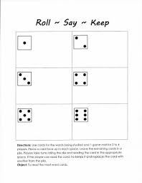**ROLL, SAY, KEEP:** *A template is available in the worksheet section of this binder (page 129) and a PDF is available on the Literacy website)*

Use sight word cards for the list being studied and 1 game mat. Place a card, face up, in each space. Leave the remaining cards in a pile. Players take turns rolling the die and reading the cards in the appropriate space. If the player can read the card, they keep it and replaces the card with another from the pile. Placing the cards face up gives the students more exposure to the words that need to be learned.

**ROLL TO WRITE A WORD:** *(templates available in the worksheet section of this binder (page 131) and a PDF of the grid is available on the Literacy website)*

1. 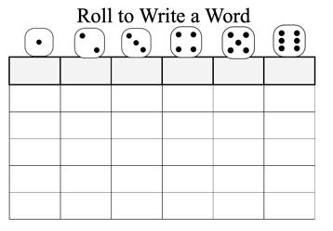Select six words from the book that the student is reading. Print one word at the top of each column.
2. Determine how many times the student will roll a word to read and write.
3. The student rolls a dice and reads the word under the rolled number.
4. The student writes the word in a box below the selected word.

**ROLL AND RETELL:** *(templates available in the worksheet section of this binder (page 133) and a PDF of grid available on the Literacy website)*

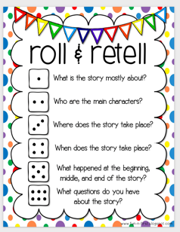This activity is a comprehension activity where the student rolls one dice to determine which comprehension question/s they will answer.

1. What is the story mostly about?
2. Who are the main characters?
3. Where does the story take place?
4. When does the story take place?
5. What happened at the beginning, middle and end of the story?
6. What questions do you have about the story?

**SMALL WHITE BOARD ACTIVITIES**

**WORD GAMES:** Use the whiteboard to replace paper grids.

TIC TAC TOE grid

HANGMAN grid

ALTERNATE HANGMAN ACTIVITIES grid

**PHONEMIC AWARENESS ACTIVITIES:** Begin these as oral activities that can be extended to written activities on the whiteboard.

**Word Beginnings – Onsets:** Teaching students about onsets (i.e., the first sound in a word) helps them recognize common chunks within words. This can help students learn about word families, decode new words when reading, and spell words when writing.

**Oral Steps**

1. Tutor says a word
2. Student repeats the word back and then isolates the onset (first sound)
3. Level up: by themselves or with support, the student tries to think of another word that has the same onset

**White board procedures**

1. Tutor writes a word on the white board
2. Student repeats the word back and then underlines or circles the onset (first sound)
3. Level up: by themselves or with support, the student writes another word that has the same onset

**Some examples:**

baker /b/ dinner /d/ happy /h

puppy /p gentle /j/ s peak /sp/

**Word Endings – Rhymes:** Recognizing rhymes is a phonemic awareness skill and is important for reading success. Rhyming requires that students listen closely for sounds within words. This helps them to recognize patterns in language, learn about word families. and makes it easier for them to read new words.

**Oral Steps:**

1. Tutor says a word pair.
2. Student repeats the word pair and then shows a thumbs up if the words rhyme, or a thumbs down if the words don’t rhyme.

**White board procedures**

1. Tutor writes a word pair on the white board.
2. Student reads the words silently and then out loud.
3. On the count of three both the tutor and student put their thumbs up or down (rhyme or not) at the same time. Do they match?

**Some examples**:

hop/mop wet/jet sad/mad

ran/fan yes/me d out/pig

dog/pot run/fun

**ALTERNATE GAMES and ACTIVITIES**

**SENTENCE STRIPS**

Print a sentence from a story you have just read on a long strip of paper. Have the student cut out each word. Scramble the words and have the student put the sentence back together again. Sometimes you can make a new sentence and/or a silly sentence with the same words.

Add more nouns or names and create new sentences.

**FOLD AND CUT BOOKLETS** *Templates are available in the worksheet section of this binder (pages 135 and137). A PDF is available on the Literacy website.*

Use small paper booklets as a closing activity to your tutoring session. The students can write and/or draw about the book they have read to you. You could also use the booklet for a total lesson. Ask the student to dictate a short story for you to write down. They then can illustrate it and read it back to you.

*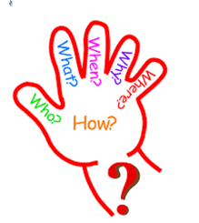***WWWWWH**

*A template is available in the worksheet section of this binder (page 139) and a PDF of the grid is available on the Literacy website)*

The 5 W’s & 1 H were designed to help students understand the details of what they read. One way to locate and remember these details is to run through the **five Ws**: and one H: who, what, where, when, why and how.

**Who**: Identify the characters in their reading selection e.g. Who is the passage about?

**What**: Identify the events or actions in the selection e.g. What is happening in the story?

**Where:** Identify all the places in the selected passage e.g. Where is the story taking place?

**When**: Identify all the time factors in the reading passage e.g. When is this happening?

**Why**: Identify the causes for events or actions e.g. Why did this happen?

**How**: Identify the manner in which events took place e.g. How did this happen?

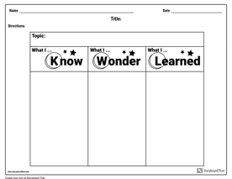**KWL:** *A template is available in the worksheet section of this binder (page 141) and a PDF of the grid is available on the Literacy website)*

This worksheet Know, Wonder, and Learned (K-W-L) is a reading strategy to help guide students through a text. Use this resource to track what your student knows (K), wants to know (W), and learned (L) about a nonfiction topic,

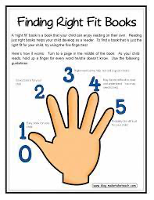

**FINDING RIGHT FIT BOOKS?** *A template is available in the worksheet section of this binder (page 143)*

This is a quick and easy way to help a student find a 'just right' books. Ask them to turn to a random page in the book and read it. For every word that they don't know, they hold up a finger. Use the following guidelines to help the student decide it they want to read the book.

**0 or 1 –** Most probably too easy.

**2 –** A good choice that will give the student a reasonable challenge and learn new words.

**3 –** The student might need some help, but still a good choice if they're up for a challenge.

**4 –** May be too difficult for the student to read on their own.

**5 –** Most probably a bit too advanced, try a different book.

**GAMES WITH SOUNDS**

*These games help students focus on the sounds of letters.*

**TALKING LIKE TURTLES**

Stretching words out or talking slowly “like a turtle might” can help students learn that words are made of sounds.  Select four or five words from the book they have been reading.  Then say each word very slowly, doing your best to say each sound, and ask your student to figure out which word you just said.  Next, ask your student to select 4 or 5 words to say the words “like a turtle,” and see if you can guess the word.

**PRESTO CHANGO**

This game focuses on word families.  A student who knows the word *cat* and the word family –*at*, for example, can figure out many related words: *bat, hat, mat, pat*, and so on. Select a word family, and think of several words that belong to it.  Now, using cat as an example, say to your student, “Let’s start with *cat*.  If we take the /*c*/ off, we have /-*at*/.  Now add /*m*/ and PRESTO CHANGO what do we have?

**WORD LADDERS**

An extension of Presto Chango, this involves having students move from one word to another by adding, subtracting, or changing one letter at a time.  Try to connect the final word to the first word in some way.  Here is an example: *read* (change a letter; this is a small, rounded piece of glass often used in jewelry) … *bead* (subtract a letter; this is the opposite of good) … *bad* (add a letter; this means having no hair) …  *bald* (change a letter; this is a round toy) …*ball* (change a letter; this is the opposite of short) …*tall* (change a letter; you pay this when you drive) … *toll* (change a letter; a screwdriver or hammer is one of these) … *tool* (change a letter; Yesterday we ___ a test) … *took* (change a letter; this is what you read) … *book!*

**WHICH ONE DOESN’T BELONG?**

This activity is sometimes called *Odd Word Out*.  It’s a variation of the *Sesame Street* sketch that asks viewers to decide which three things belong together.  To play it, assemble sets of three words, two of which share a feature.  For example, with beginning sounds, you might have *cat, cake*, and *tree*.  With word families, you could select *pin, tin*, and *tip*.  Say each set of words to your student and ask, “Which one doesn’t belong?”  Then remember to ask “Why?”

**RIDDLES**

This game asks students to solve a riddle by figuring out a word that matches clues.  To play, select four or five words.  These can be words from the book your student has read or words related to a word family.  Then develop a brief riddle for each.  For example, using the word *fish*, you could say, “I am a living creature.  I live in the water.  I rhyme with *dish*.  What am I?”

**CLAPPING WORDS**

This game helps students understand the concept of syllables.  Students do not need to know lots of syllable rules, but it is helpful for them to recognize that long words have “chunks.”  To play the game, start with a short poem or song (or other text that your student knows).  Then invite your student to read the text along with you and to clap the syllables in the text while reading.  To add variety, you and your student could march to the text, taking a step for each syllable.

**GAMES WITH WORDS**

*The games are useful for developing sight vocabulary, providing additional practice with new vocabulary words, and of course — having fun!*

**WORD THEATER**

This game is based on *Charades*. To play it, first select several words from a text your student has read. Put each word on a small slip of paper, and put the slips of paper in a cup.  Then play the game like *Charades*.  Ask your student to select a word and act it out (no words allowed!) while you guess the word.  Then you take a turn.  This is also a fun family game.

**20 QUESTIONS**

Select a word from a text you have read with your student. Tell your student to guess the word you have in mind by asking up to 20 *yes* or *no* questions.

**RING A WORD**

Using a book that the student has read, print a selection of words on a whiteboard or chalkboard. Direct them to ring each word you call out. Give them a point for each word they find.

This game can be played with two players using different colours to mark the words they find.

**FUN WITH SENTENCES**

**By The Numbers**

Objective: To create sentences by the numbers by following the directions.

• Write a 2-word sentence in which each word has 2 letters.

• Write a 3-word sentence in which each word has 3 letters.

• Write a 4-word sentence in which each word has 4 letters.

• Write a 5-word sentence in which each word has 5 letters.

**Tongue Twister Sentences**

Objective: To write tongue twister sentences where most of the words in the sentence begin with the same letter.

For example: The six sleek sheiks’ sixth sheep is sick.

**Out, Word Out!**

Objective: To write sentences of at least 6 words without including one of the most common words: the, of, and, to, a, in that, is, I, it for, as

**ABC Sentence**

Objective: To create a sentence in which all the words are in alphabetical order. Sentences may begin with any letter of the alphabet.

For example: My niece opens packages quickly.

**Build Ups:**

Objective: Use the pattern of blanks and word below to build a sentence. Other words can be substituted for the word tigers.

__________ __________ __________ tigers __________ __________ tigers __________ __________  
__________ __________ tigers  
Tigers __________

**GAME CARDS**

This section includes templates for ONE TO ONE word cards. Included are the following:

DOLCH WORD CARDS

CARDS for LUCKY DUCK and PIG

STOP CARDS

INDIVIDUAL LETTER CARDS

DOLCH WORD CARDS

|  |  |  |  |
| --- | --- | --- | --- |
| a | and | away | big |
| blue | can | come | down |
| find | for | funny | go |
| help | here | I | in |
| is | it | jump | little |
| look | make | me | my |

|  |  |  |  |
| --- | --- | --- | --- |
| not | one | play | red |
| run | said | see | the |
| three | two | to | up |
| we | where | yellow | you |
| all | am | are | at |
| be | black | brown | but |

|  |  |  |  |
| --- | --- | --- | --- |
| came | did | do | eat |
| for | get | good | have |
| he | into | like | must |
| new | now | on | out |
| please | pretty | ran | ride |
| saw | say | she | so |

|  |  |  |  |
| --- | --- | --- | --- |
| that | there | this | too |
| under | want | was | well |
| when | what | who | will |
| with | yes | after | again |
| an | any | ask | by |

|  |  |  |  |
| --- | --- | --- | --- |
| could | every | fly | from |
| give | going | had | has |
| her | him | his | how |
| just | know | let | live |
| may | of | old | once |
| open | over | put | round |

|  |  |  |  |
| --- | --- | --- | --- |
| some | talk | take | thank |
| them | then | think | walk |
| were | when |  |  |
|  |  |  |  |
|  |  |  |  |
|  |  |  |  |

|  |  |  |  |
| --- | --- | --- | --- |
| NOT | NOT | NOT | NOT |
| NOT | NOT | NOT | NOT |
| NOT | NOT | NOT | NOT |
|  |  |  |  |
|  |  |  |  |

|  |  |  |  |
| --- | --- | --- | --- |
|  |  |  |  |
|  |  |  |  |

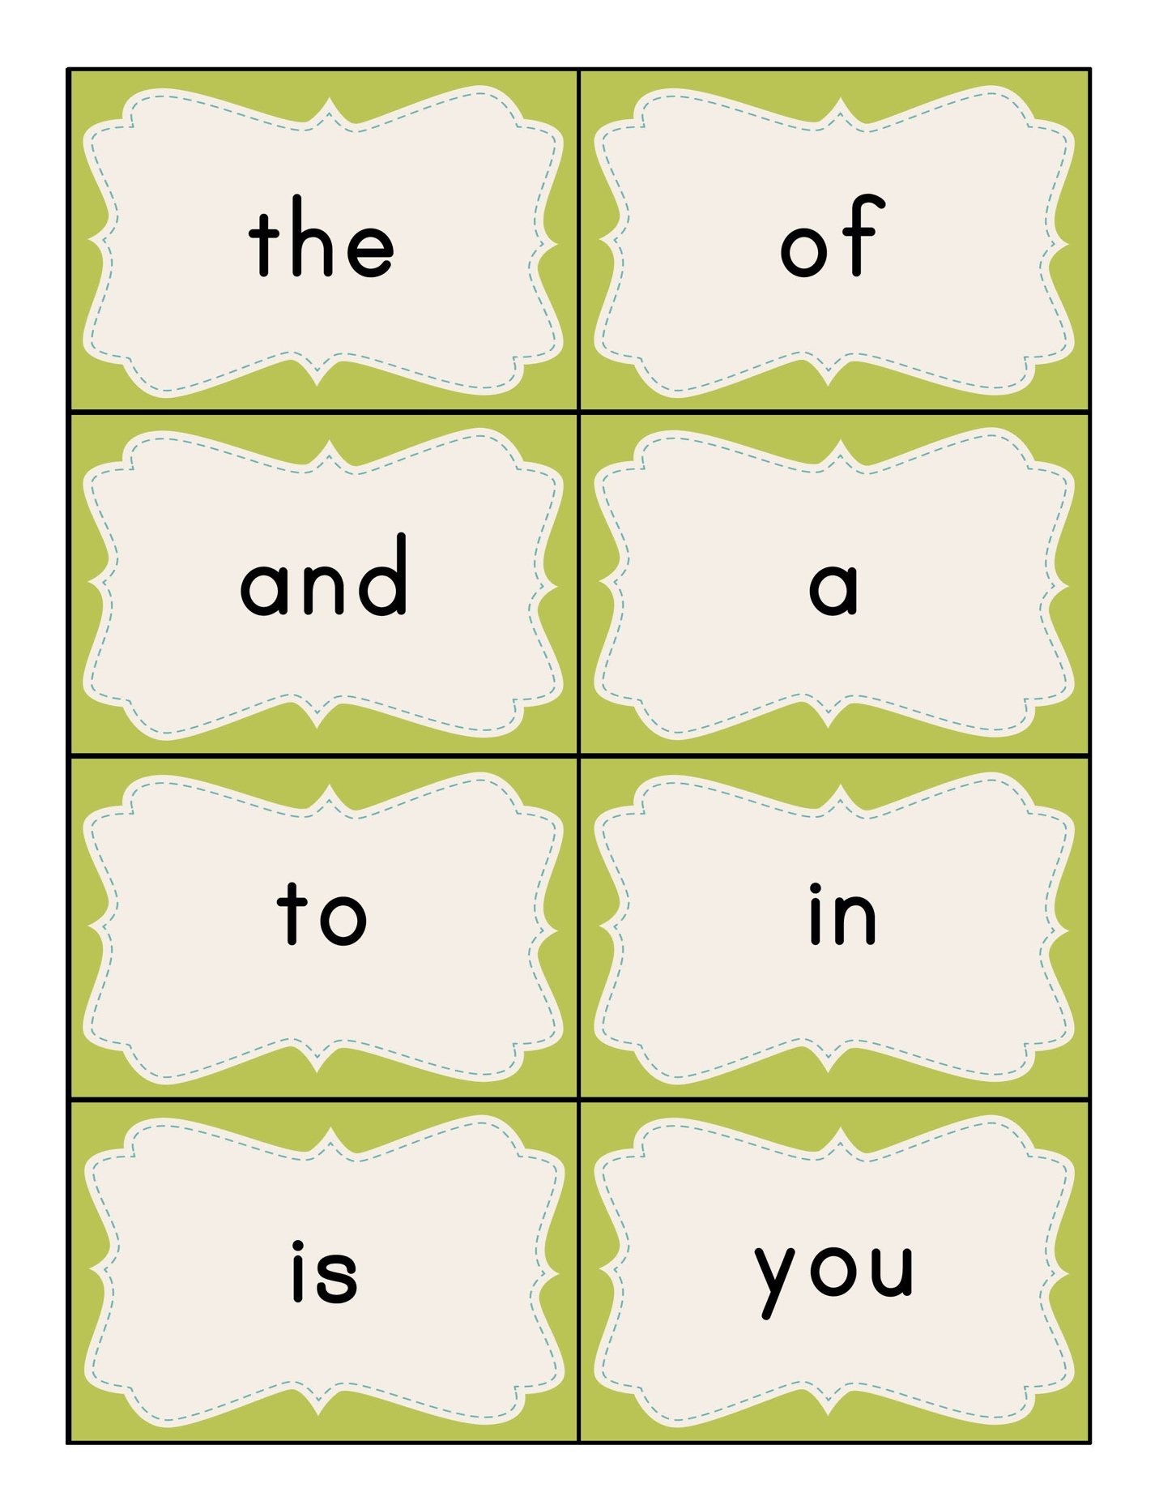

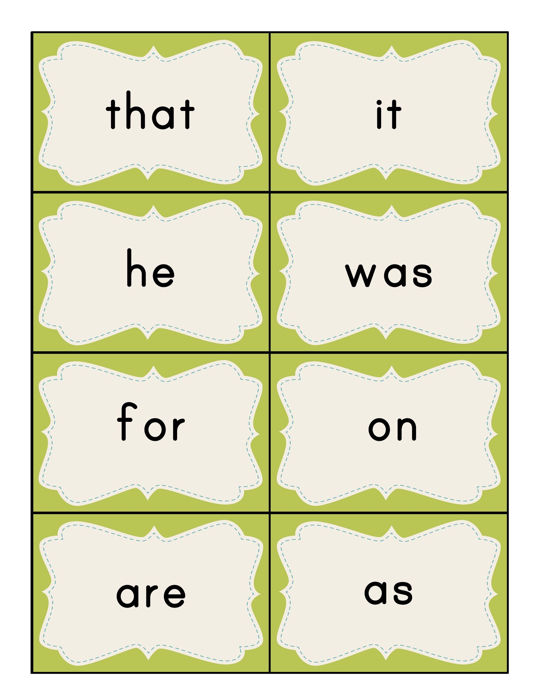

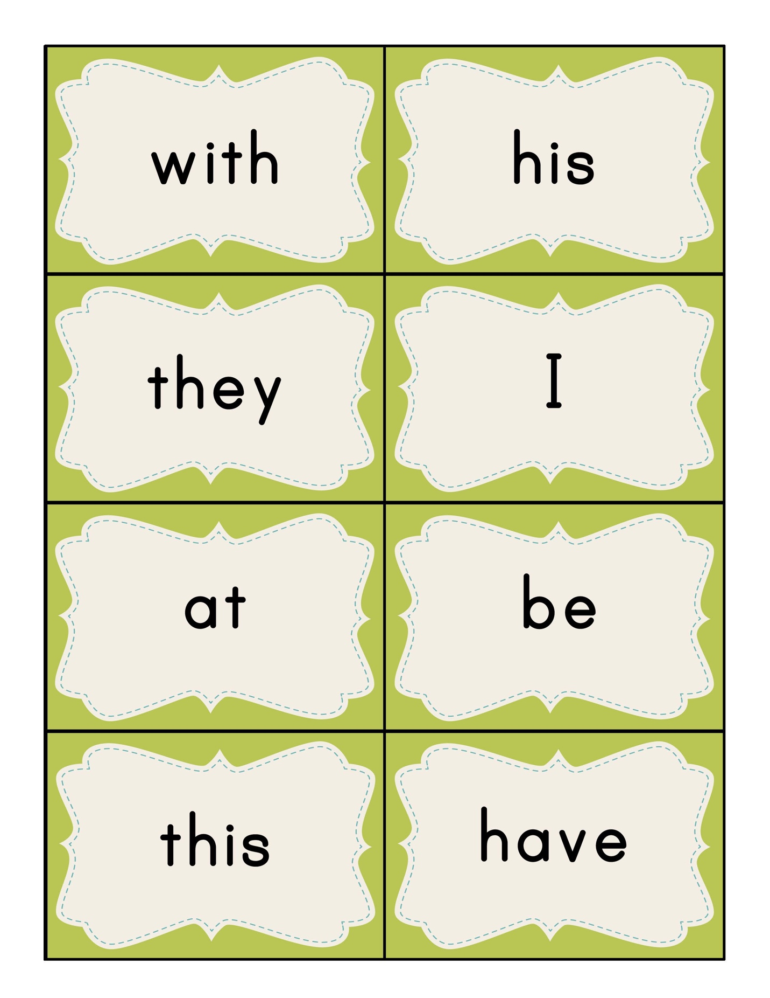

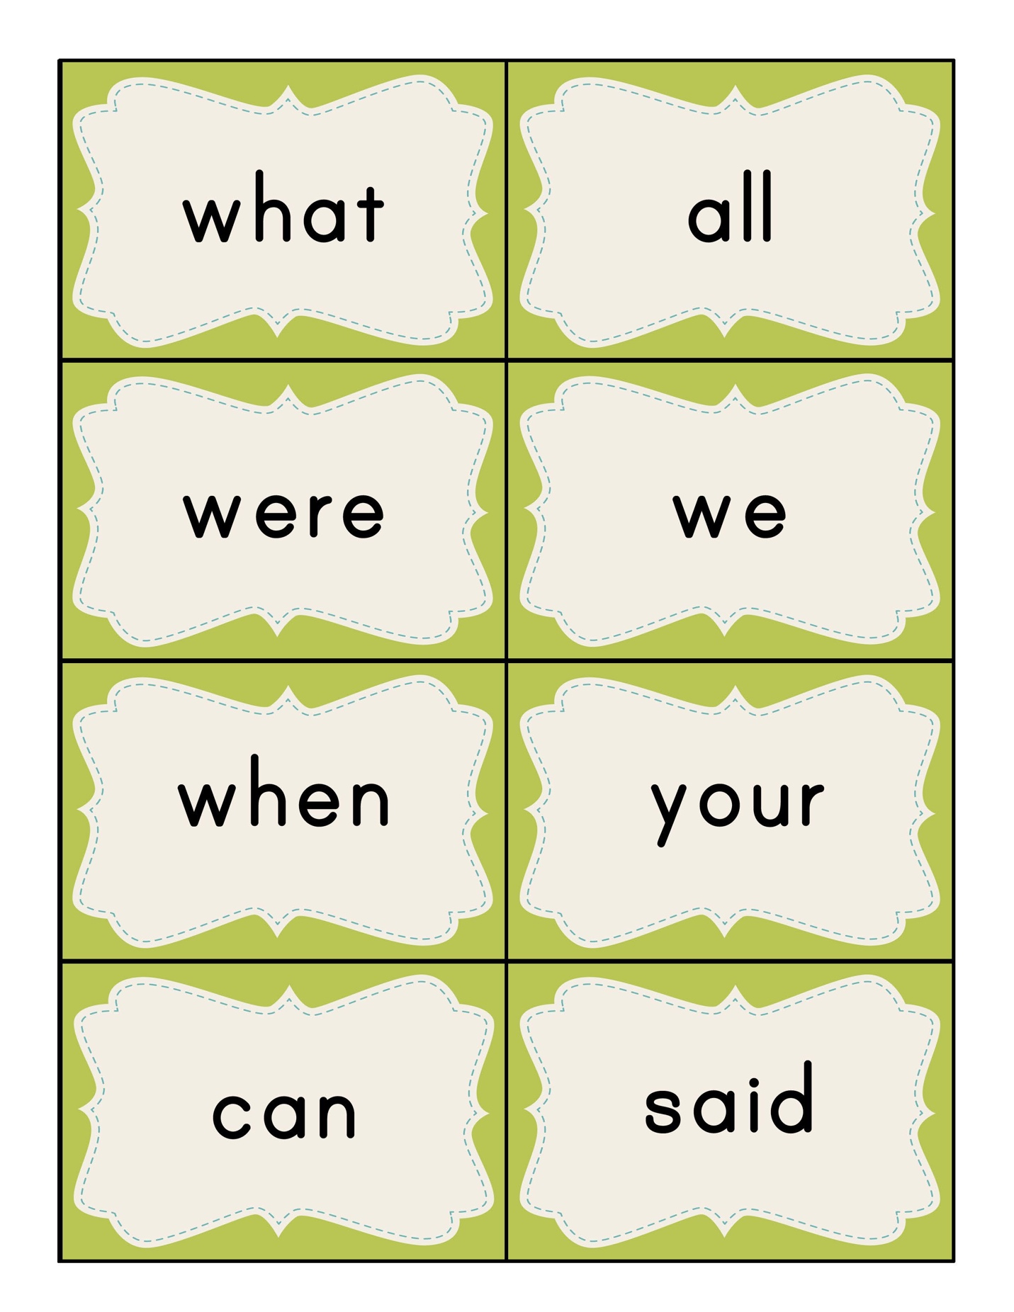

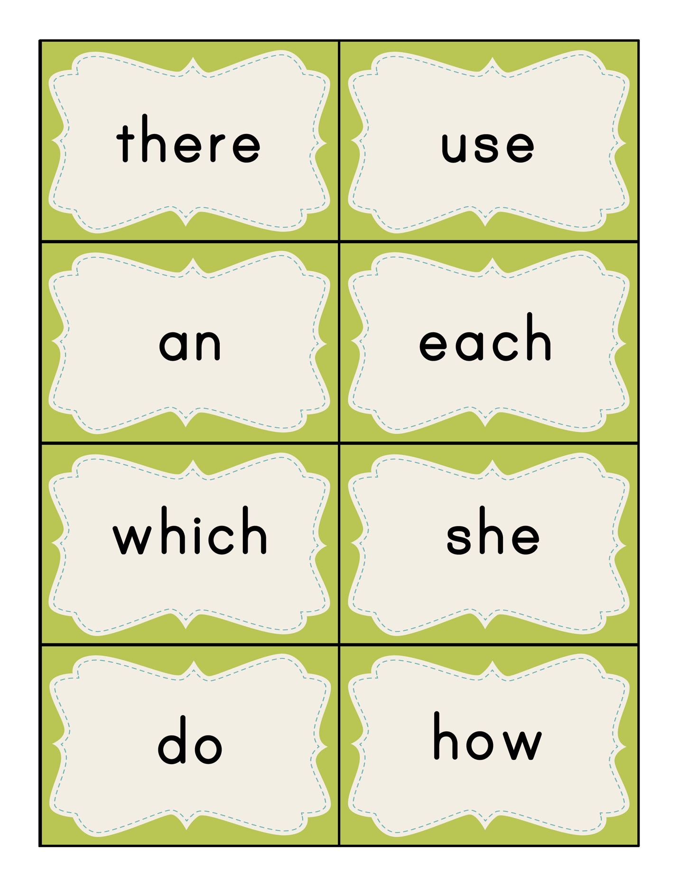

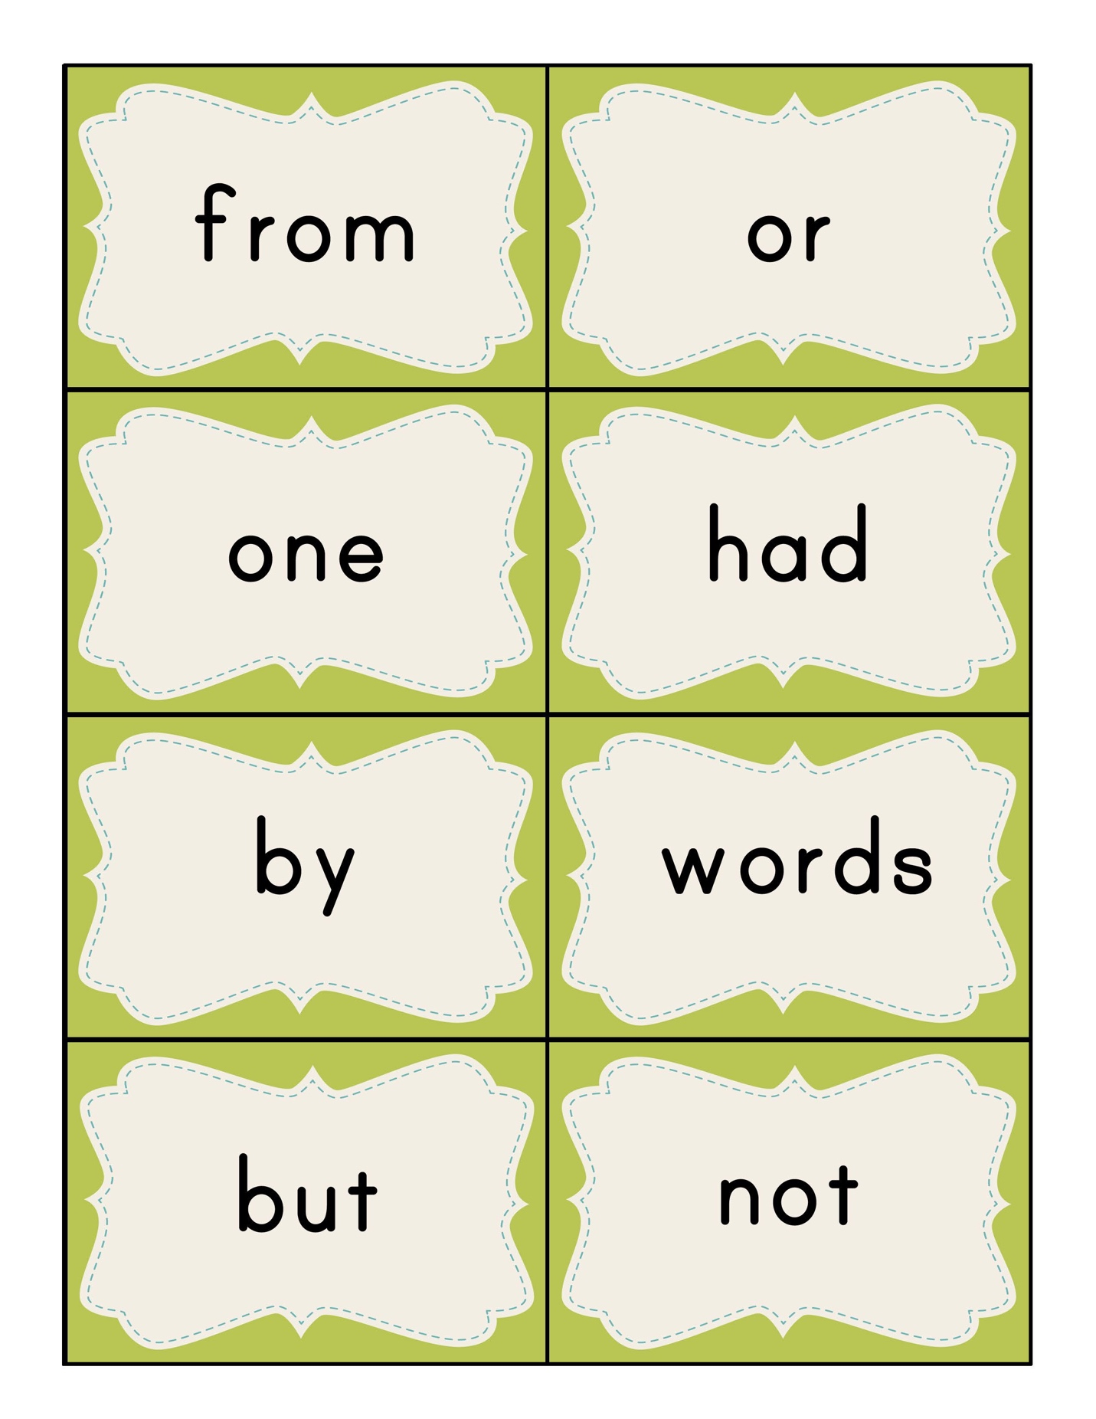

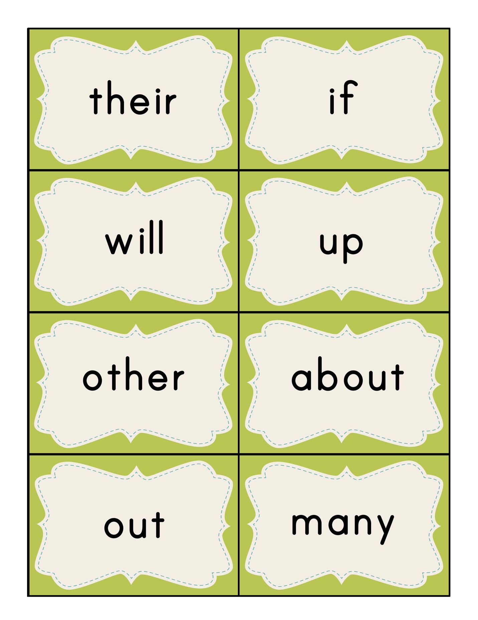

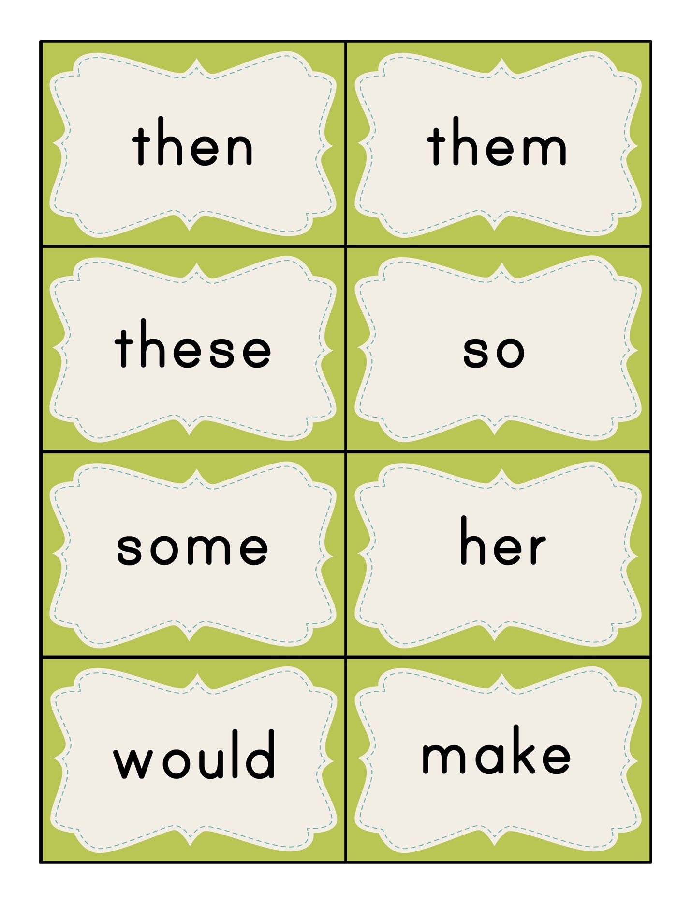

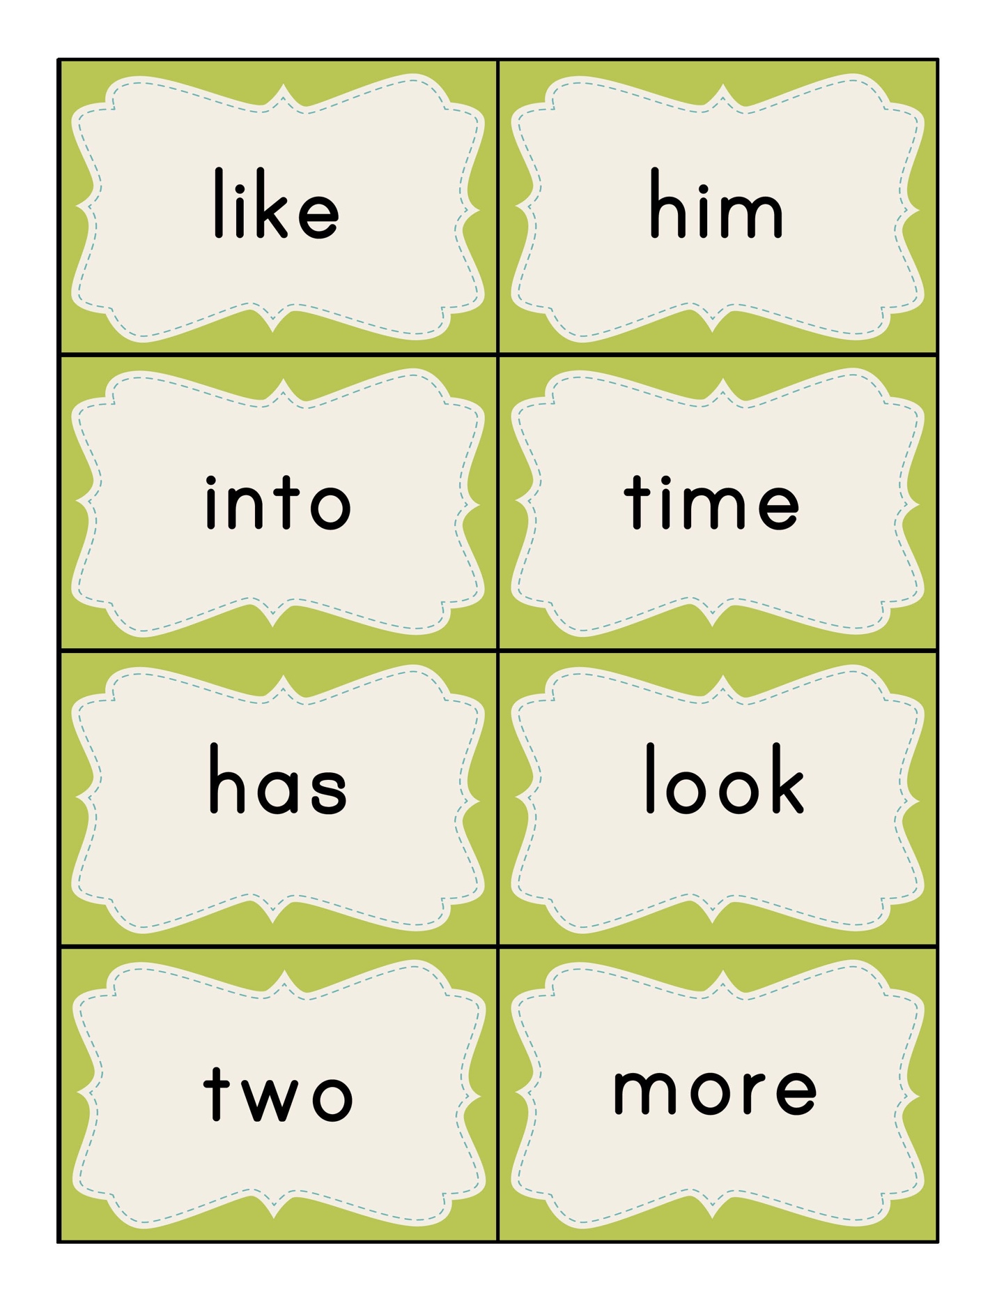

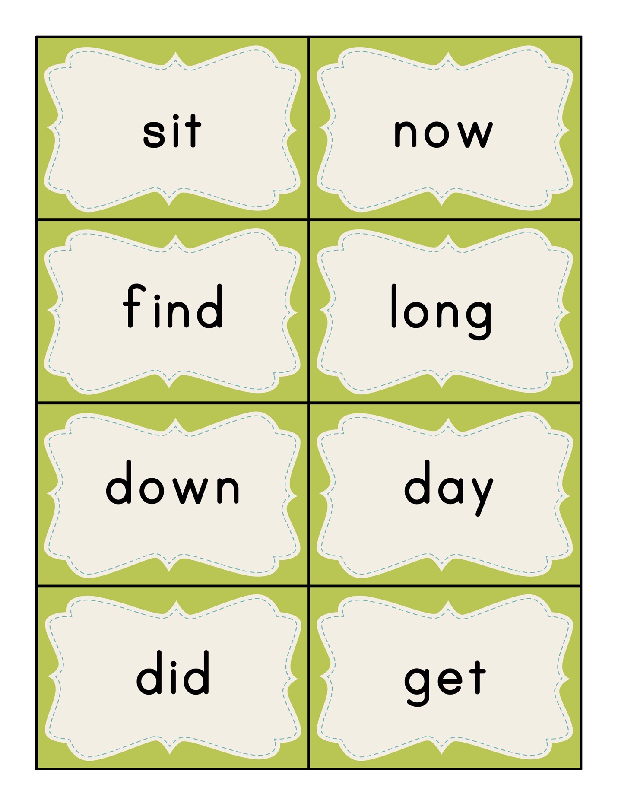

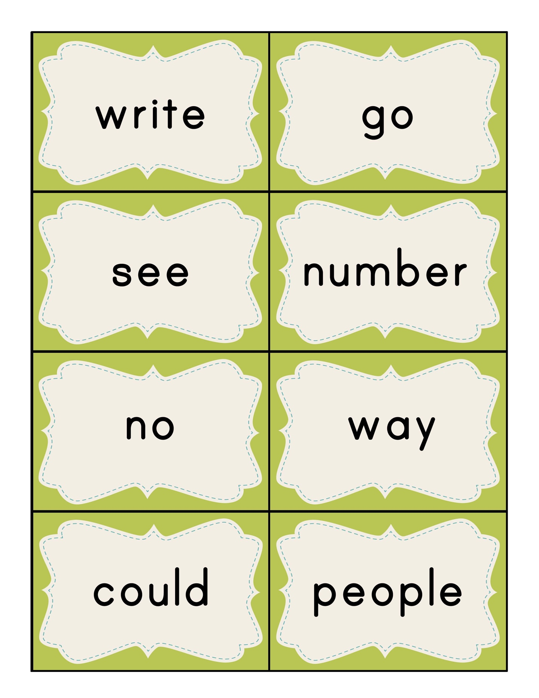

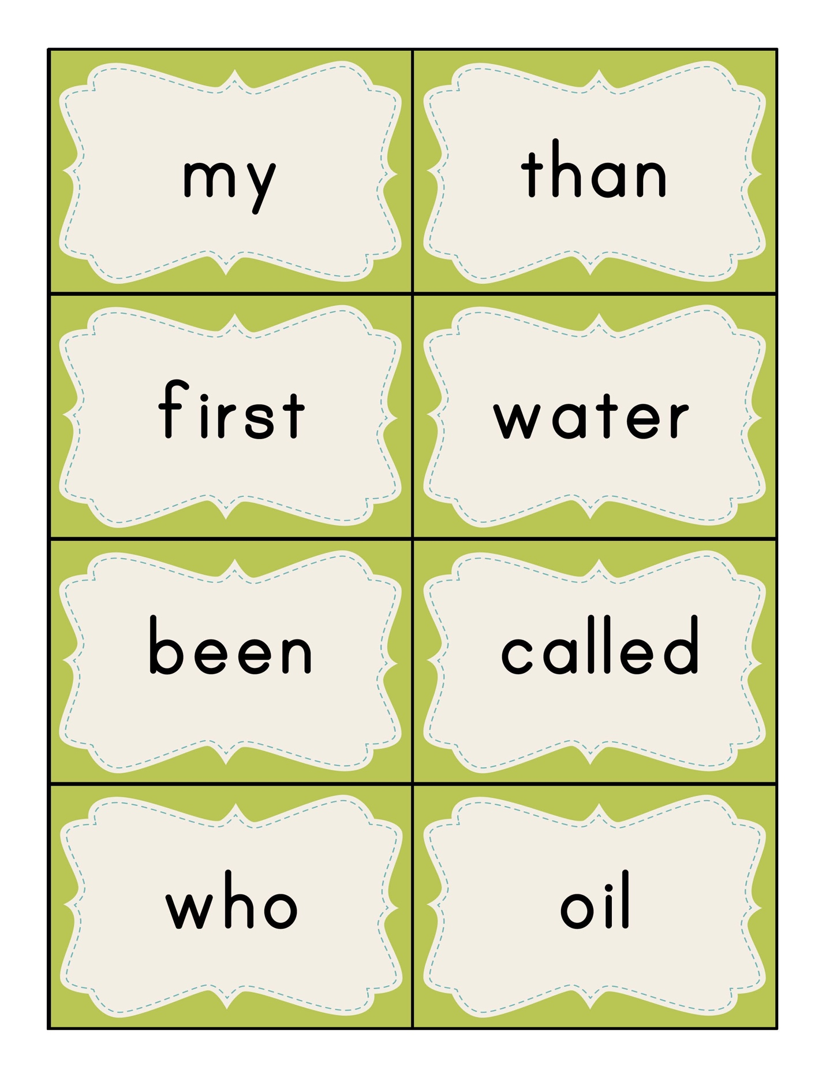

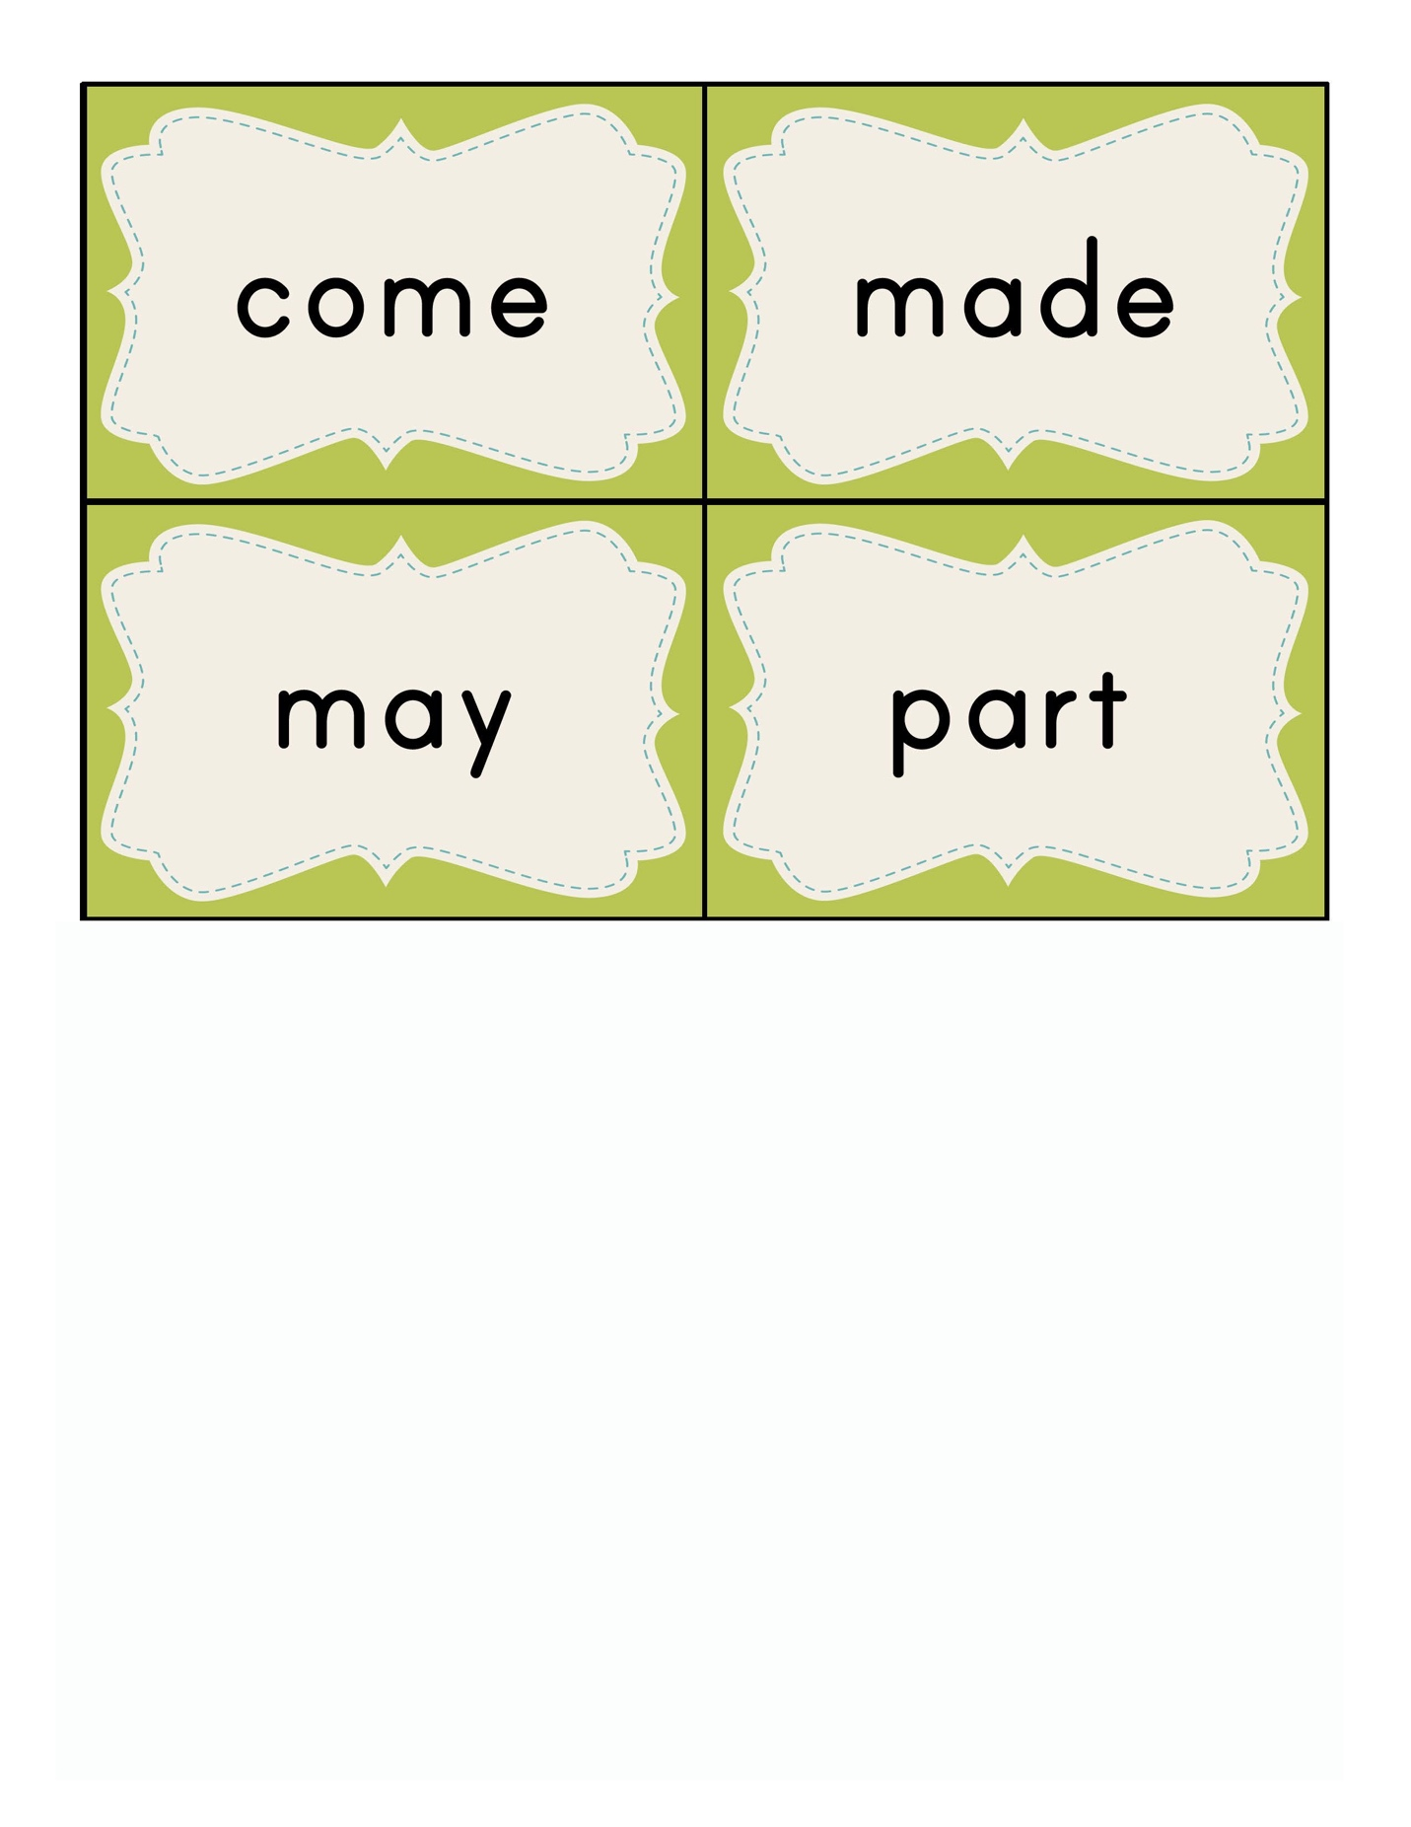

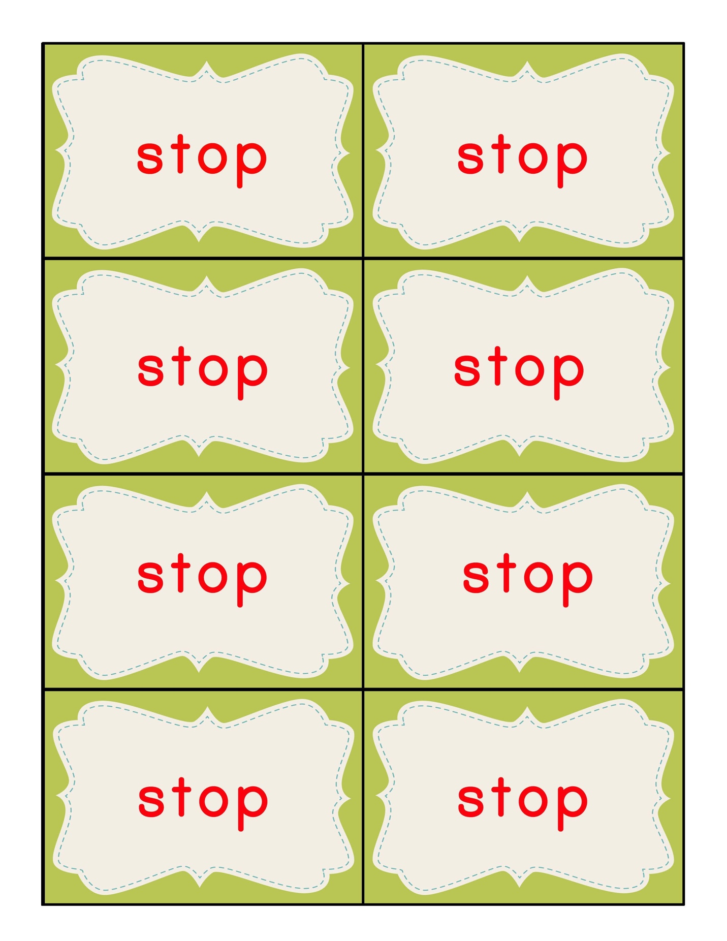





**INDIVIDUAL LETTER CARDS**

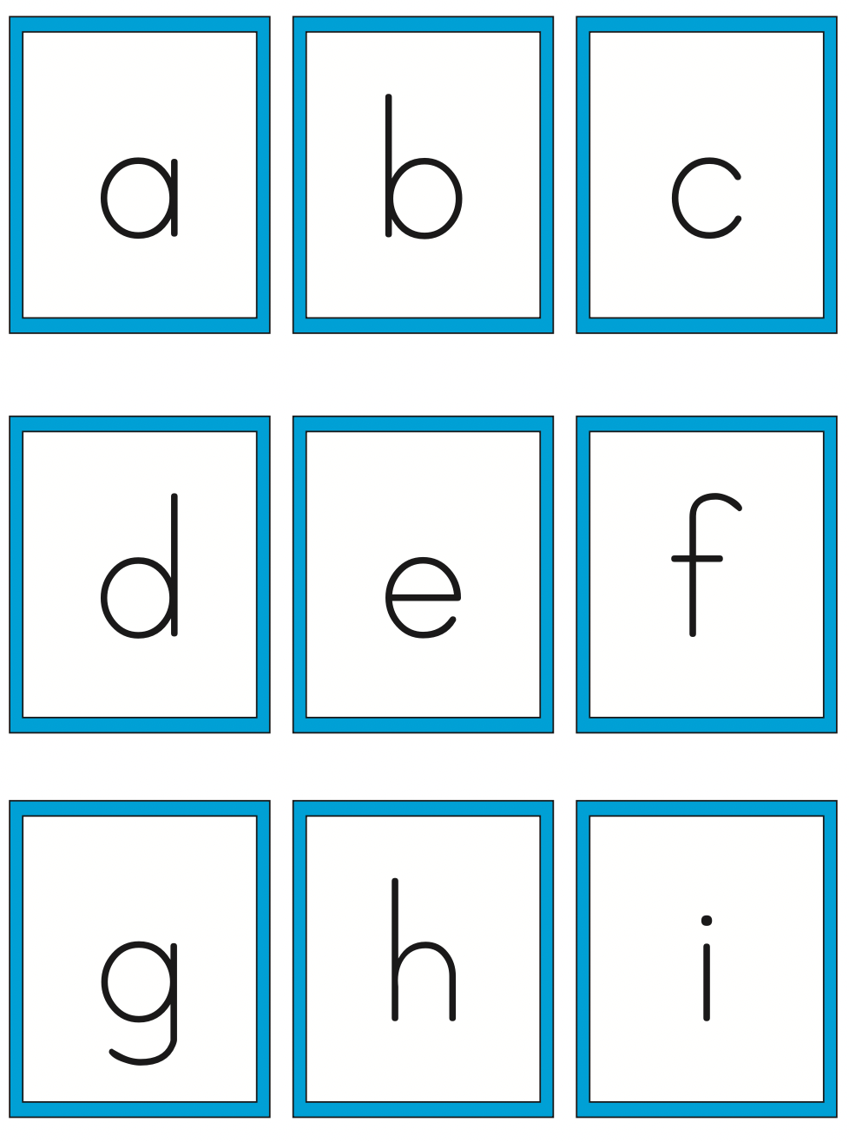

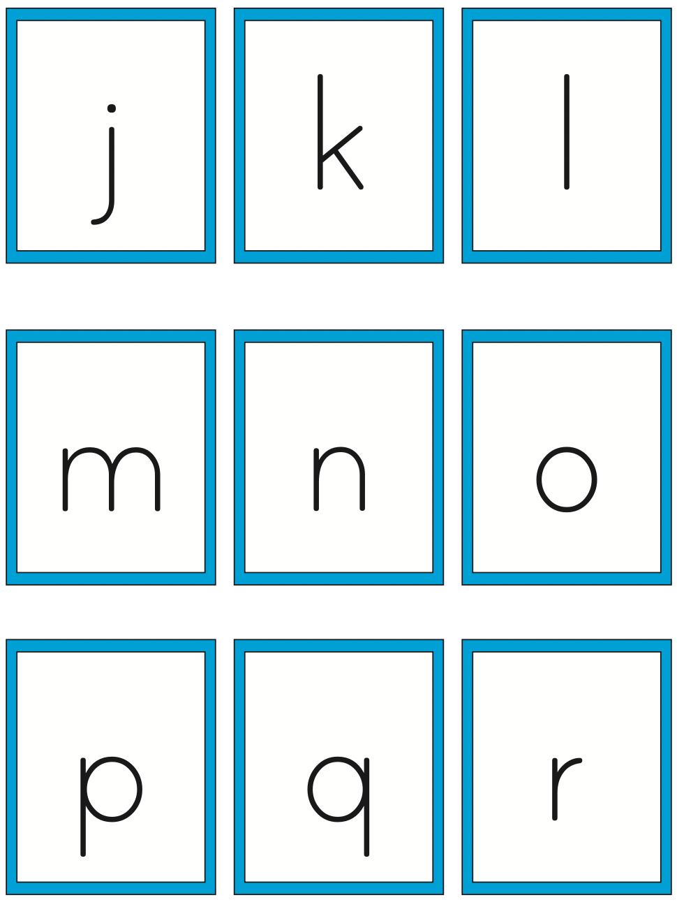

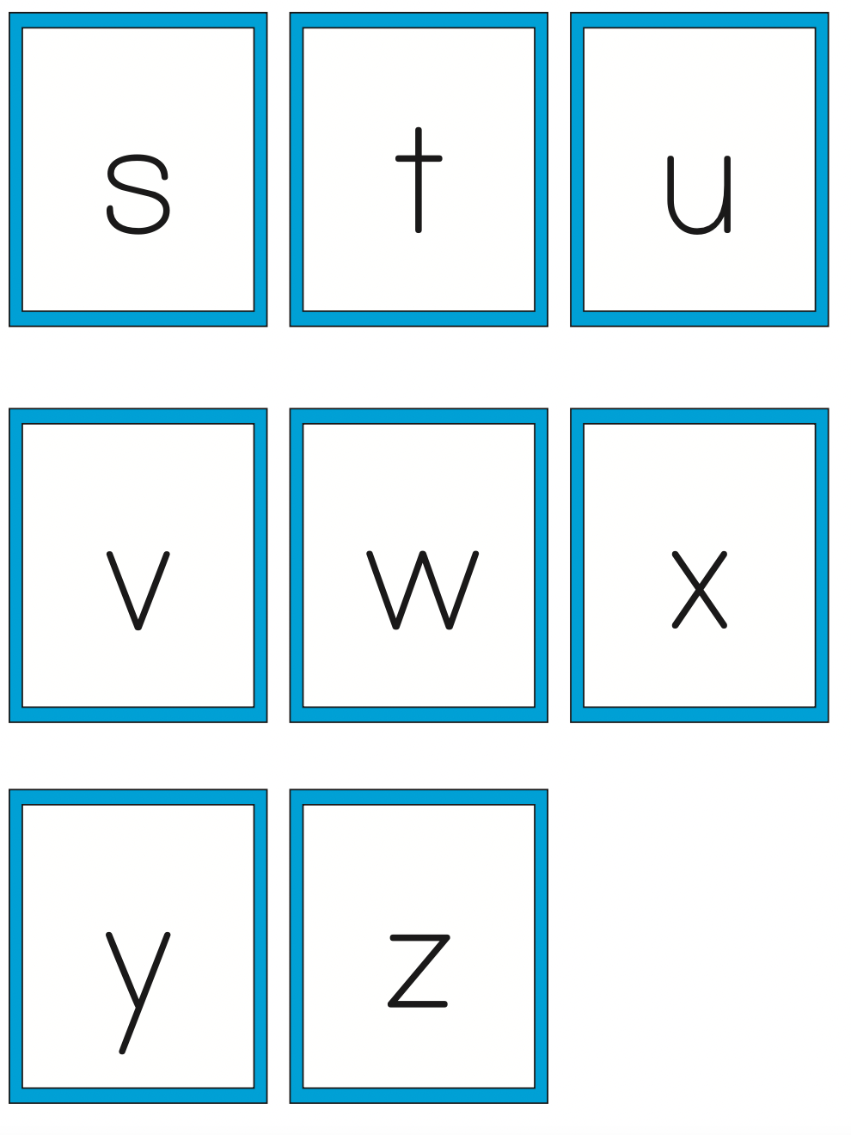

**GAME DESCRIPTIONS**

The handouts in this section describe individual games for ONE TO ONE. Included are the following.

GO FISH

CONCENTATION

WORD WAR

STOP

LUCKY DUCK

PIG and STOP

GAME BOARDS

TIC TAC TOE

HANGMAN

ROLL, PICK a LETTER, WRITE a WORD

ROLL, SAY, KEEP

ROLLTO WRITE A WORD

ROLL and RETELL



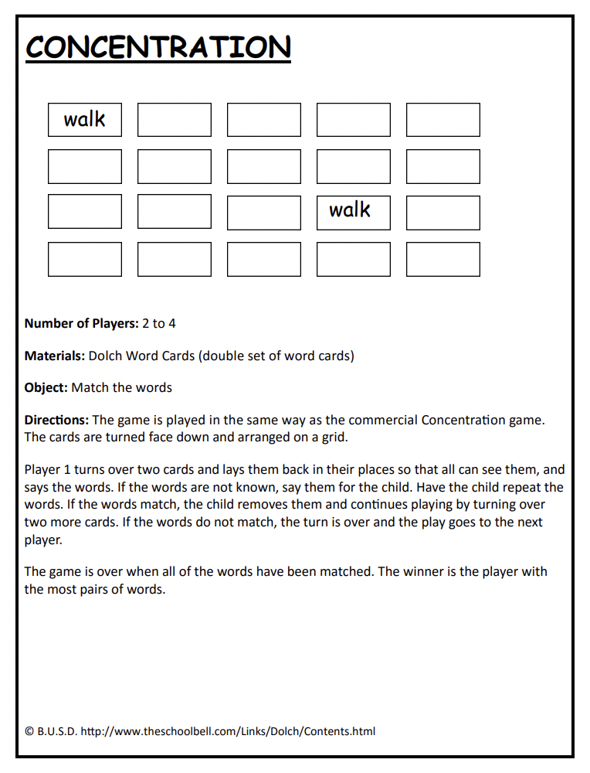

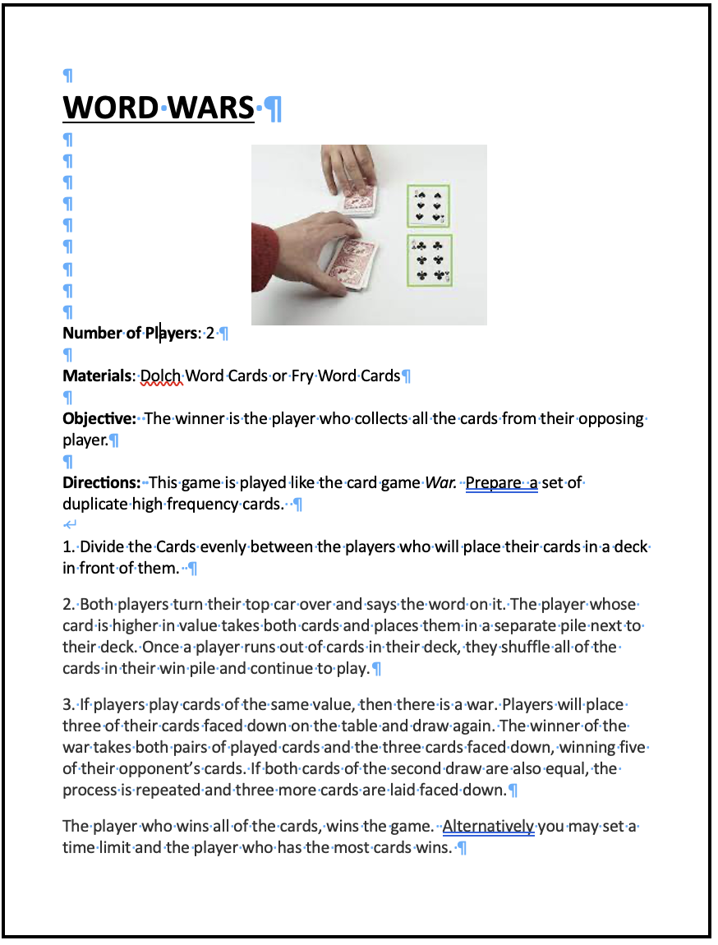

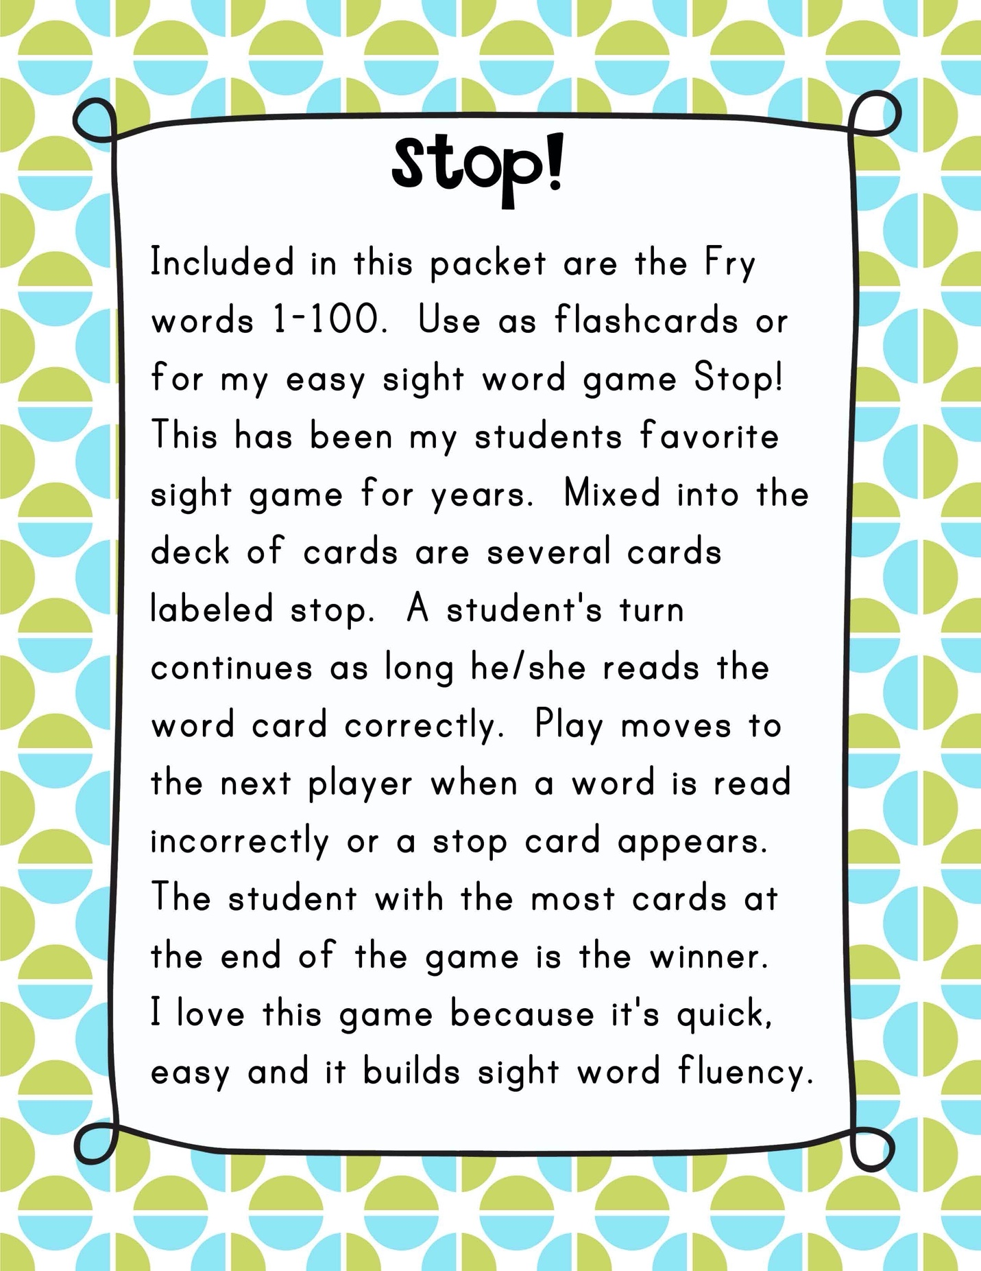

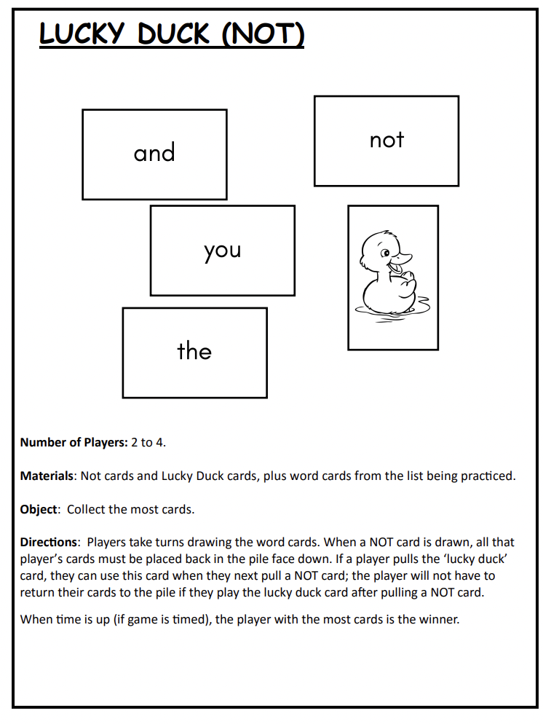

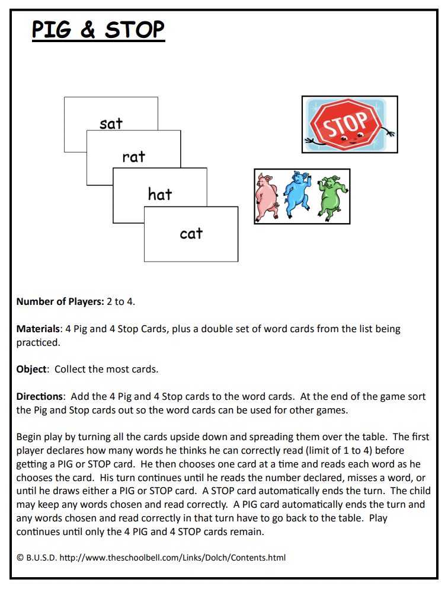

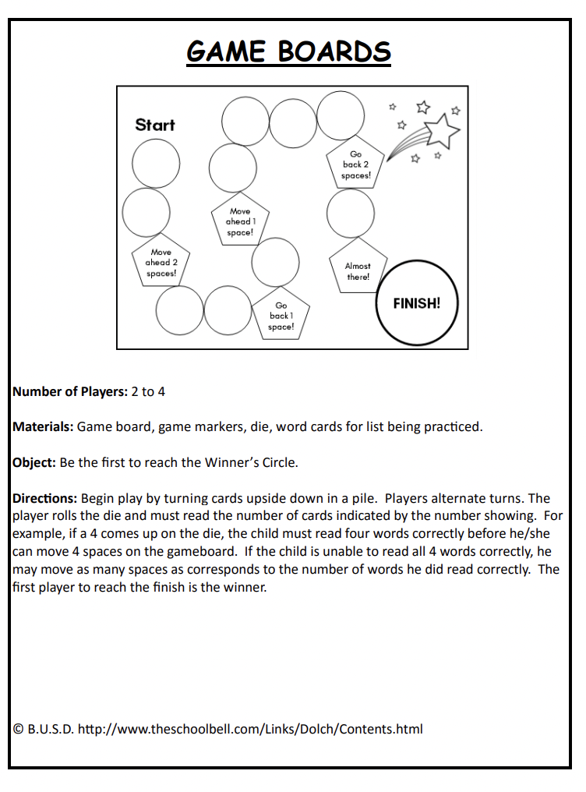

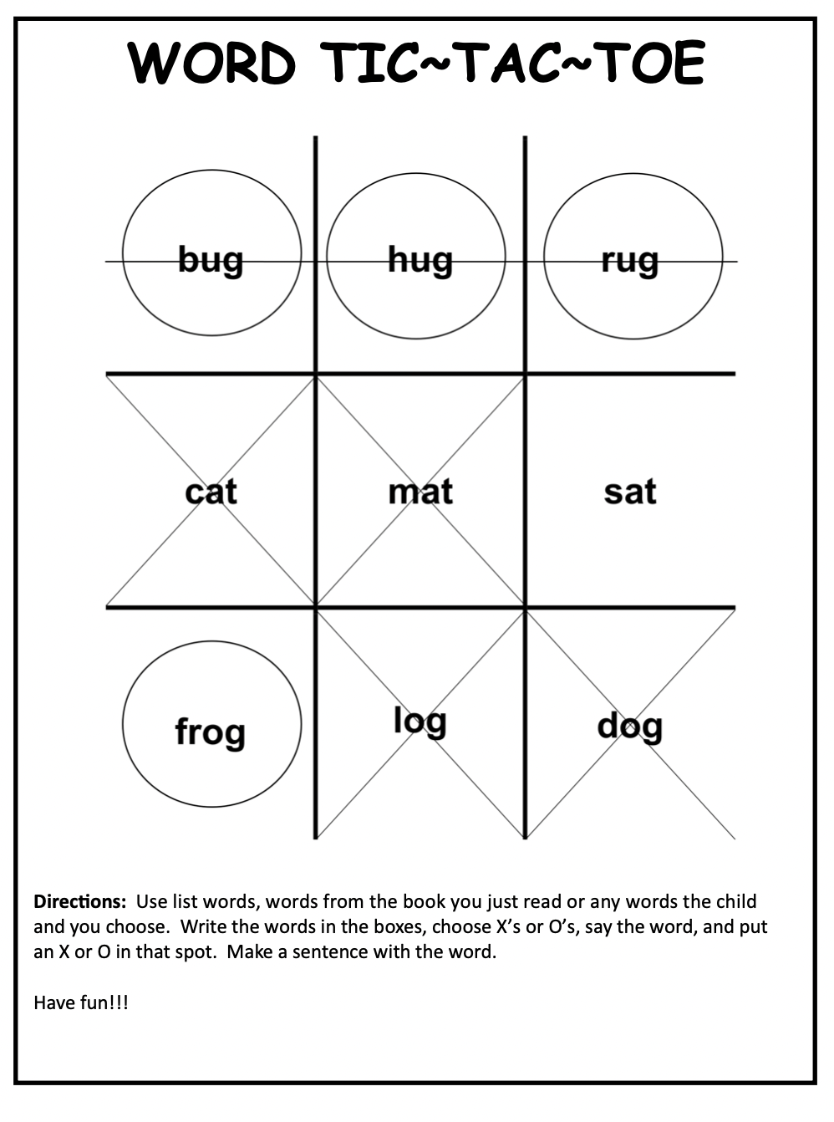



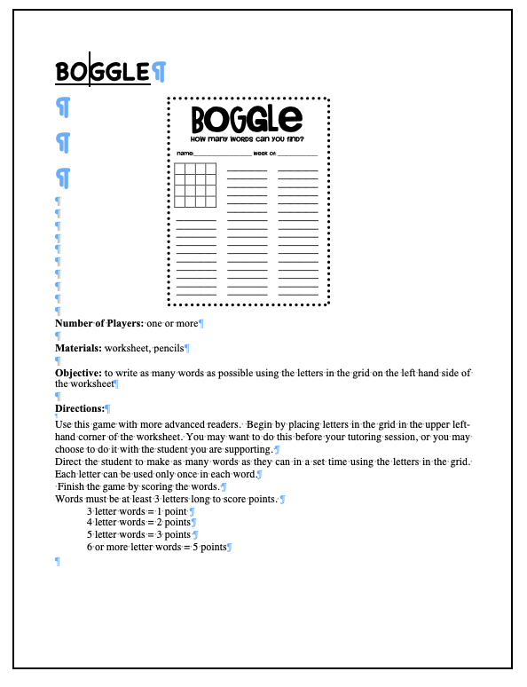



**\**

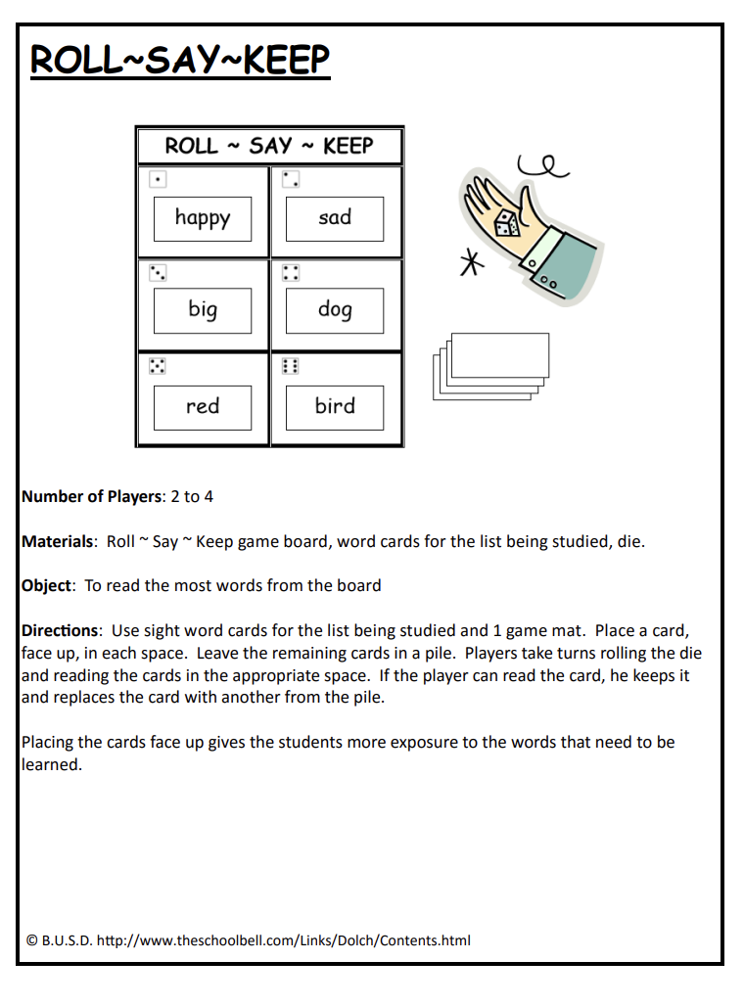

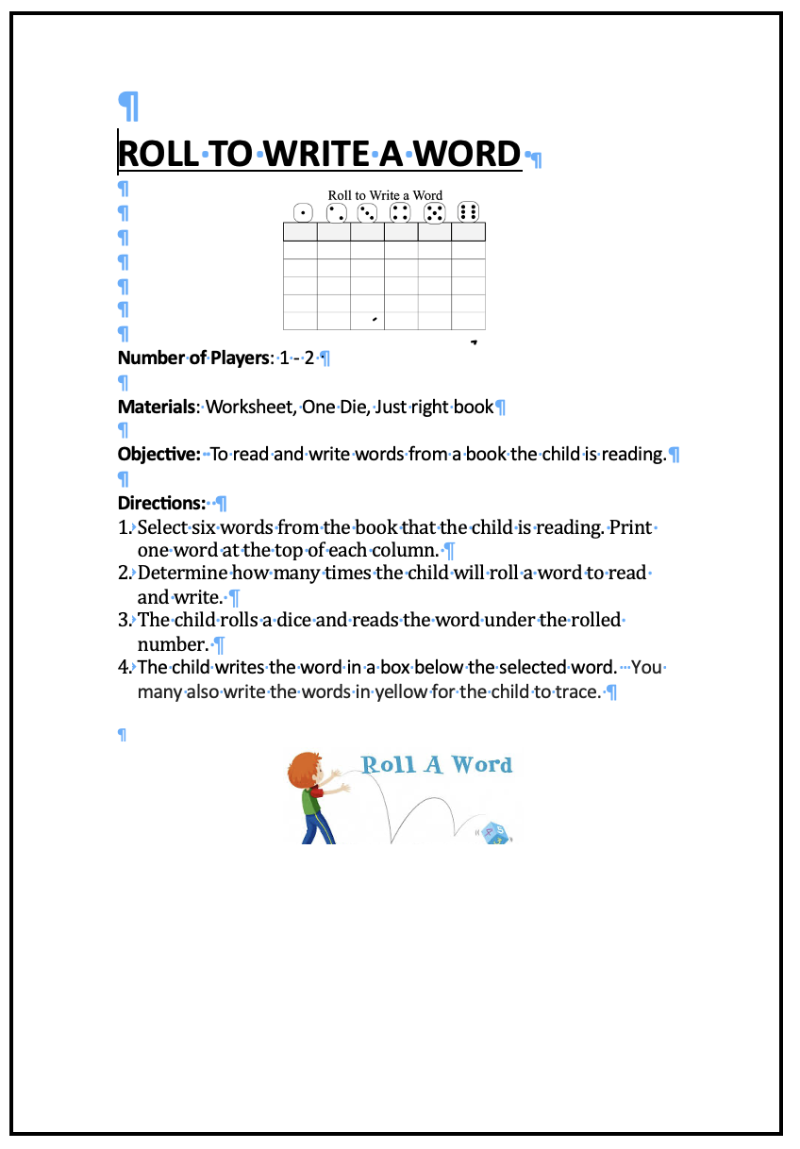

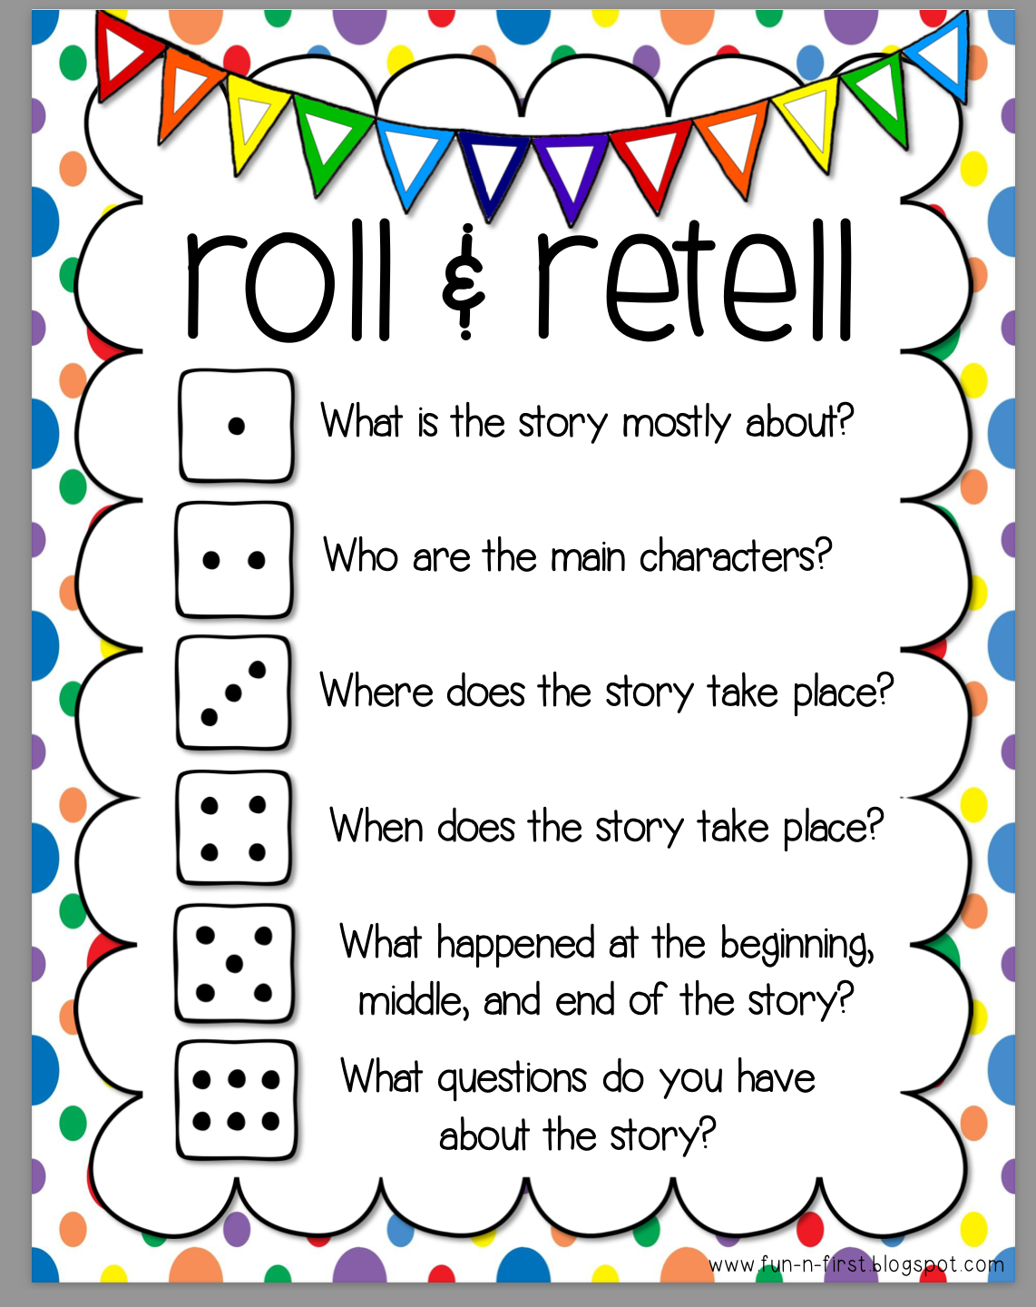

**WORKSHEETS**

This section includes templates for worksheets to accompany ONETO ONE games and activities. Included are the following:

GAME BOARDS

TIC TAC TOE

HANGMAN

ALTERNATE HANGMAN FORMAT

BOGGLE

SPELLING BATTLESHIP

ROLL, PICK a LETTER, BUILD a WORD

ROLL, SAY, KEEP

ROLLTO WRITE A WORD

ROLL and RETELL

HOW? WHO? WHAT? WHEN? WHY? WHERE?

K, W, L

FOLD AND CUT BOOKLETS

FINDING RIGHT FIT BOOKS

WORD SEARCHES

